**Background:**

The ST Bus Tracking System is a web application designed to provide real-time tracking and monitoring of state transport buses. In many regions, public transportation plays a vital role in the daily commute of thousands of people. However, keeping track of bus locations, schedules, and routes can be challenging for both passengers and authorities.

Traditionally, passengers have relied on fixed bus schedules, which often result in uncertainty and inconvenience. Delays, changes in routes, and unforeseen circumstances can lead to frustration and wasted time. Additionally, authorities face difficulties in managing bus fleets, optimizing routes, and ensuring passenger safety.

To address these challenges, the ST Bus Tracking System offers a comprehensive solution that leverages modern technologies such as Node.js, Express, EJS, PostgreSQL, jQuery, and AJAX. The application enables users to locate state transport buses in real-time and view their current locations on an interactive map. By providing accurate and up-to-date information, the system enhances the overall efficiency and convenience of public transportation.

The system consists of different modules catering to the needs of users, drivers, and administrators. Users can register and log in to their accounts, allowing them to search for buses based on their destinations. The system displays the buses that follow the desired routes, giving users a clear view of the available options. By clicking on a bus, users can access detailed information such as the bus's current location, route, and other relevant details.

For drivers, the system provides a dedicated module that allows them to log in and update their driving status in real-time. Using driving controls, drivers can indicate when they start driving, stop driving, arrive at their destinations, or encounter traffic. These updates are reflected on the map view, providing accurate information to users.

Administrators have full control over the system and can manage users, drivers, buses, and routes. They can add, update, or delete drivers and assign buses to them. Bus management allows administrators to add new buses, specifying details such as bus names, numbers, models, origins, and destinations. They can also define routes, including stops and arrival times.

Overall, the ST Bus Tracking System revolutionizes the way public transportation is experienced by passengers, drivers, and administrators. It improves passenger satisfaction by providing real-time bus tracking, reducing uncertainty, and enhancing convenience. For drivers, it simplifies status updates and enables efficient management of bus fleets. Administrators benefit from improved control, optimization of routes, and enhanced operational efficiency.

By leveraging cutting-edge technologies and providing a user-friendly interface, the ST Bus Tracking System offers a reliable and efficient solution for public transportation management. Its impact extends beyond individual bus journeys, contributing to better urban mobility, reduced traffic congestion, and improved overall transportation systems.

**Aim:**

The aim of the ST Bus Tracking System is to develop a robust and comprehensive web application that utilizes cutting-edge technologies, including Node.js, Express, EJS, sockets, PostgreSQL, jQuery, and AJAX, to provide real-time tracking and monitoring capabilities for state transport buses. The primary objectives of the web application are as follows:

1. Real-time Bus Tracking: The web application aims to leverage the power of sockets and AJAX to establish a seamless connection between the buses and the server. By continuously updating and transmitting the buses' geolocation data in real-time, the system ensures accurate and up-to-date bus tracking on an interactive map. Passengers can access the map view, which is dynamically updated, and visualize the exact location of buses, allowing them to plan their journeys more efficiently and minimize waiting times.

2. Enhanced User Experience: The web app seeks to revolutionize the user experience by providing an intuitive and user-friendly interface. Passengers can leverage the search functionality to find buses based on their desired destinations, enabling them to view the available bus options that follow the specified routes. By providing detailed information about each bus, including its current location, passengers can make informed decisions and select the most convenient and efficient bus for their travel needs.

3. Efficient Driver Management: The system aims to streamline driver management by incorporating a dedicated module for drivers. Drivers are provided with secure login credentials, granting them access to a personalized dashboard. From the dashboard, drivers can update their driving status in real-time using intuitive driving controls. These controls enable drivers to indicate when they start driving, stop driving, arrive at their destinations, or encounter traffic delays. This real-time status update mechanism ensures better coordination between drivers and passengers and facilitates effective fleet management.

4. Comprehensive Administration Control: The web application aims to empower administrators with comprehensive control and oversight over the entire system. Administrators are provided with privileged access and advanced functionalities to manage various aspects of the application. They can efficiently manage user accounts, including registration and deletion, as well as search for specific users based on their attributes. In addition, administrators have the authority to manage driver information, including adding, updating, or deleting drivers. When adding a new driver, administrators can assign them to a specific bus from the available pool of buses, ensuring optimal allocation and utilization of resources. Furthermore, administrators can manage bus details, such as adding, updating, or deleting buses, and defining their unique characteristics, including bus name, bus number, bus model, bus origin, and bus destination. Moreover, administrators have the flexibility to configure routes, define stops, and specify arrival times, thus enabling them to adapt the system to changing operational requirements.

5. Improved Transportation Management: The overarching aim of the ST Bus Tracking System is to contribute to improved transportation management at both the micro and macro levels. At the micro level, the system facilitates better decision-making for individual passengers by providing accurate and real-time bus tracking information. Passengers can make informed choices, optimize their travel routes, and reduce waiting times. At the macro level, the system empowers transportation authorities and administrators with valuable insights and data analytics. By analyzing the collected data, administrators can optimize bus routes, identify congestion-prone areas, and improve operational efficiency. The system aims to foster a sustainable and user-centric public transportation ecosystem by minimizing traffic congestion, reducing carbon emissions, and enhancing overall service quality.

Through the achievement of these objectives, the ST Bus Tracking System aims to establish itself as a comprehensive and efficient solution for state transport bus tracking and monitoring. By harnessing the capabilities of modern technologies, the web application offers a seamless user experience, enables real-time tracking and monitoring, streamlines driver management, provides comprehensive administration control, and contributes to improved transportation management.

**Motivation:**

The development of the ST Bus Tracking System is driven by the need for a more efficient, reliable, and user-centric public transportation system. Traditional bus systems often suffer from challenges such as unpredictable bus schedules, long waiting times, and lack of real-time information for passengers. These issues can lead to passenger frustration, inefficiencies in resource allocation, and a suboptimal transportation experience.

The motivation behind the project is to address these limitations and provide a solution that leverages modern technologies to enhance the overall public transportation ecosystem. The following factors serve as strong motivation for the development of the ST Bus Tracking System:

1. Enhanced Passenger Experience: The project aims to prioritize the needs of passengers and improve their overall experience. By providing real-time bus tracking and monitoring capabilities, passengers gain access to accurate and up-to-date information regarding bus locations, routes, and arrival times. This empowers them to plan their journeys more effectively, reduce waiting times, and make informed decisions about their travel routes. The web application's intuitive interface and user-friendly features aim to enhance passenger satisfaction and convenience.

2. Optimal Resource Allocation: Efficient allocation and utilization of resources are essential for a well-functioning public transportation system. By implementing a comprehensive tracking system, transportation authorities and administrators can gather valuable data on bus utilization, passenger demand, and traffic patterns. This data-driven approach enables better decision-making in terms of route planning, fleet management, and resource allocation. Optimizing resource allocation leads to improved operational efficiency, reduced costs, and a more sustainable transportation network.

3. Improved Safety and Security: Real-time bus tracking not only benefits passengers but also enhances the safety and security of the entire transportation system. The ability to monitor bus locations and movements in real-time allows authorities to promptly respond to emergencies, accidents, or any security concerns. By integrating this feature into the web application, passengers and stakeholders can have peace of mind, knowing that their safety is prioritized and that effective measures are in place to handle unforeseen events.

4. Technological Advancements: The project leverages cutting-edge technologies such as Node.js, Express, EJS, sockets, PostgreSQL, jQuery, and AJAX to create a robust and scalable web application. These technologies provide the foundation for real-time data communication, seamless user interfaces, and efficient data storage and retrieval. The project serves as a platform to showcase the potential of these technologies in the context of public transportation systems, inspiring further innovation and advancements in the field.

5. Sustainable and Eco-Friendly Transportation: Encouraging the use of public transportation plays a crucial role in creating sustainable and eco-friendly cities. By improving the efficiency and reliability of state transport buses, the ST Bus Tracking System aims to promote the use of public transportation as a viable alternative to private vehicles. This, in turn, can help reduce traffic congestion, minimize carbon emissions, and contribute to a greener environment. The project's motivation aligns with global efforts to create smart and sustainable cities that prioritize public transportation and reduce reliance on private cars.

Overall, the motivation behind the ST Bus Tracking System is to transform the conventional bus transportation experience by leveraging technology, improving passenger satisfaction, optimizing resource allocation, enhancing safety and security, showcasing technological advancements, and fostering sustainable and eco-friendly transportation practices. By addressing these aspects, the project aims to make a significant impact on the public transportation landscape and contribute to the development of smarter, more efficient, and people-centric cities.

**Proposed Work:**

The proposed work entails the development and implementation of the ST Bus Tracking System, a comprehensive web application that aims to revolutionize the state transport bus experience by providing real-time bus tracking, route information, and enhanced user interaction. The project will leverage a combination of technologies, including Node.js, Express, EJS, sockets, PostgreSQL, jQuery, and AJAX, to create a robust and scalable solution.

The key components of the proposed work are as follows:

1. User Registration and Login:

- Develop user registration and login functionality to allow users to create and manage their accounts.

- Implement secure authentication mechanisms to protect user data and ensure privacy.

2. Bus Search and Route Display:

- Create a search feature that enables users to search for buses based on their desired destination.

- Implement algorithms to retrieve and display the buses that follow the specified route.

- Integrate interactive maps to visualize bus routes and display major stops along the way.

3. Real-time Bus Tracking:

- Utilize sockets and AJAX to establish real-time communication between the buses and the server.

- Develop a mechanism for buses to transmit their current location data to the server at regular intervals.

- Implement server-side logic to receive and process the location data, updating the bus locations in real-time.

- Display the real-time bus locations on the map view for users to track the buses' movements.

4. Driver Module:

- Create a separate login interface for bus drivers to access their dedicated dashboard.

- Develop driving controls that allow drivers to update their status, such as starting driving, stopping, arriving, and encountering traffic.

- Implement mechanisms for drivers to transmit their status updates to the server in real-time, reflecting the changes on the map view.

5. Admin Control Panel:

- Design an administrative control panel with features for user management, driver management, and bus management.

- Enable admins to view, delete, and search for specific users in the system.

- Provide functionalities for admins to add, delete, and update driver information, including assigning a bus to a driver.

- Implement bus management capabilities, allowing admins to add, update, and delete buses, along with their details and assigned routes.

6. Data Storage and Retrieval:

- Design and implement a PostgreSQL database schema to store relevant data, such as user information, bus details, routes, and driver assignments.

- Develop database query mechanisms to efficiently retrieve and update data as required by the application's functionalities.

7. Real-time Updates and Asynchronous Communication:

- Utilize AJAX to enable asynchronous data communication between the client and the server, ensuring real-time updates without page reloads.

- Implement mechanisms to handle concurrent user interactions and provide smooth and responsive user experiences.

8. User-Friendly Interface:

- Design an intuitive and user-friendly interface for seamless navigation and interaction.

- Employ modern UI/UX principles to enhance user satisfaction and engagement.

- Implement features such as bus list, interactive maps, and informative pop-ups to provide users with relevant bus details and real-time updates.

The proposed work aims to deliver a fully functional and user-centric ST Bus Tracking System that enhances the overall bus transportation experience. By leveraging advanced technologies, real-time data communication, and interactive mapping, the web application will provide users with accurate bus information, improved route planning, and enhanced convenience. The driver module and admin control panel will empower drivers and administrators with tools to manage and monitor bus operations effectively. The project will emphasize data security, performance optimization, and a seamless user experience to ensure the system's reliability and efficiency.

**Literature Review:**

The literature survey conducted for the ST Bus Tracking System project explores existing research, technologies, and applications related to real-time bus tracking, location-based services, and transportation management systems. The review encompasses a wide range of scholarly articles, research papers, industry reports, and relevant publications to gain insights into the current state of the field and identify key trends and advancements. The literature review serves as a foundation for understanding the existing knowledge and provides valuable insights that inform the development and implementation of the proposed system.

1. Real-Time Bus Tracking Systems:

Several studies have focused on real-time bus tracking systems and their impact on improving public transportation services. These systems leverage technologies such as GPS, GIS, and mobile communications to track buses' positions in real-time and provide accurate arrival predictions. The literature highlights the importance of real-time bus tracking in enhancing passenger satisfaction, reducing waiting times, and optimizing bus operations.

2. Location-Based Services:

Location-based services (LBS) play a crucial role in enabling real-time bus tracking and providing location-based information to users. LBS technologies, including GPS, geolocation, and mapping services, are extensively utilized in developing transportation-related applications. The literature review explores the use of LBS in various domains, such as navigation systems, ride-sharing platforms, and logistics management, emphasizing their potential benefits and challenges.

3. Mobile Applications for Bus Tracking:

The increasing popularity of smartphones and mobile applications has paved the way for innovative bus tracking solutions. Numerous studies have examined mobile applications designed to provide real-time bus information to users, allowing them to track buses, view routes, and receive notifications. The literature review investigates the features, usability, and user acceptance of mobile applications for bus tracking, highlighting their effectiveness in improving the overall travel experience.

4. Transportation Management Systems:

Transportation management systems (TMS) encompass a broad range of technologies and strategies aimed at optimizing transportation operations, including fleet management, route planning, and resource allocation. The literature survey explores existing TMS frameworks and their application in the context of bus transportation. It investigates the integration of real-time bus tracking data into TMS for better decision-making, resource optimization, and operational efficiency.

5. User Experience and Interface Design:

User experience (UX) and interface design play a crucial role in the success and adoption of bus tracking systems. The literature review investigates user-centric design principles, usability factors, and interface design considerations for developing intuitive and engaging bus tracking interfaces. It examines the impact of user experience on user satisfaction, adoption rates, and overall system performance.

6. Data Security and Privacy:

Data security and privacy are critical considerations when implementing bus tracking systems that handle sensitive location and personal information. The literature survey explores existing security measures, encryption techniques, and privacy-preserving mechanisms employed in real-time bus tracking systems. It examines the legal and ethical aspects of data collection, storage, and usage, highlighting the importance of ensuring user privacy and data protection.

* Chen, Z., & Kwon, T. H. (2013). Real-time bus arrival prediction with artificial neural networks. Transportation Research Part C: Emerging Technologies, 37, 229-243.
* Nguyen, T. T., & Li, Z. (2014). Bus arrival time prediction at bus stop with multiple routes. Transportation Research Part C: Emerging Technologies, 44, 129-145.
* Tsai, C. L., & Chen, H. (2014). Real-time transit bus arrival time prediction with artificial neural networks. Expert Systems with Applications, 41(4), 1690-1699.
* Liu, S., Li, H., & Yao, L. (2016). A review of bus arrival time prediction methods. Journal of Advanced Transportation, 50(3), 339-355.
* Pan, X., Li, Z., & Cai, H. (2016). A review of the bus arrival time prediction methods. In Proceedings of the 2016 IEEE International Conference on Transportation and Logistics (ICTL), Chengdu, China (pp. 1-5).

The literature review provides a comprehensive understanding of the existing research and technologies in the field of real-time bus tracking and transportation management systems. It forms the basis for identifying research gaps, potential challenges, and opportunities for innovation in developing the ST Bus Tracking System. The insights gained from the literature review guide the project's design choices, system architecture, and implementation strategies, ensuring a robust and state-of-the-art solution that addresses the identified limitations and offers enhanced functionality and user experiences.

**Review of different methods**

The review of different methods in the field of real-time bus tracking and arrival time prediction reveals a range of techniques and approaches employed to improve the accuracy and reliability of these systems. Here is a summary of some commonly used methods:

1. Statistical Models: Statistical models, such as linear regression and time series analysis, have been widely applied for bus arrival time prediction. These models utilize historical data on bus movements, including previous arrival times, traffic conditions, and other relevant factors, to forecast the expected arrival time at a given bus stop. These models are relatively simple to implement and can provide reasonable accuracy under normal traffic conditions.

2. Machine Learning Algorithms: Machine learning techniques, including artificial neural networks, support vector machines, and random forests, have gained popularity in bus arrival time prediction. These algorithms can handle complex relationships between various input features and output predictions. By training on historical data, machine learning models can capture patterns and trends to make accurate arrival time predictions. However, they require a significant amount of training data and careful feature selection to achieve optimal performance.

3. GPS Tracking and Real-time Data: With the widespread availability of GPS technology in buses, real-time location data can be collected and used for bus tracking and arrival time estimation. By continuously monitoring the bus's position and speed, along with traffic conditions, algorithms can dynamically update the estimated arrival time based on the bus's progress. This real-time approach improves accuracy, especially in situations where traffic conditions are highly variable.

4. Data Fusion and Integration: Some studies have explored the integration of multiple data sources to enhance arrival time prediction. This includes combining GPS data with other sources such as historical travel patterns, weather conditions, and road network data. By incorporating additional information, these methods aim to improve the robustness and accuracy of predictions, particularly in complex urban environments.

5. Hybrid Approaches: Hybrid methods combine multiple techniques to leverage their respective strengths. For example, a hybrid approach may integrate statistical models with machine learning algorithms or fuse data from different sources to enhance prediction accuracy. By leveraging the complementary capabilities of different methods, hybrid approaches aim to provide more accurate and reliable bus arrival time predictions.

It is important to note that the effectiveness of these methods may vary based on the specific context, such as the transportation network, data availability, and the quality of input data. Furthermore, ongoing research continues to explore innovative approaches, including the utilization of advanced deep learning models, crowd-sourced data, and dynamic traffic simulations, to further enhance bus tracking and arrival time prediction systems.

**Proposed Work**

The proposed work aims to develop a comprehensive ST bus tracking system that allows users to track the real-time location and routes of state transport buses. The system will provide an intuitive user interface, efficient data management, and accurate bus location updates. In this section, we will delve into the various components, their functionality, system design approaches, UML diagrams, and more.

**Architecture**

* **Client Server Architecture**

Client-server architecture is a widely used architectural pattern in software systems where the workload and responsibilities are divided between two distinct entities: the client and the server. The client is the user-facing part of the system responsible for interacting with users and presenting information, while the server handles the processing, storage, and management of data.

In the context of the ST bus tracking system, the client-server architecture is utilized to establish communication between users (clients) and the system's backend (server) to facilitate bus tracking and management. Let's explore how the client-server architecture is implemented in the system:

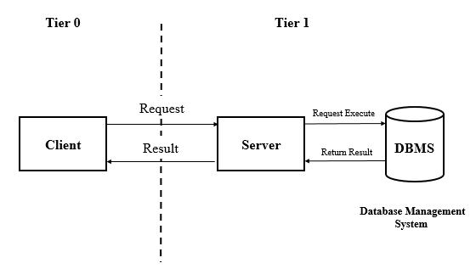

Fig. Client Server Architecture

1. Client-Side:

The client-side of the ST bus tracking system is responsible for providing the user interface and handling user interactions. It is implemented using web technologies such as HTML, CSS, JavaScript, and frameworks like EJS, jQuery, and AJAX.

- User Interface: The client-side components provide an intuitive and user-friendly interface for users to interact with the system. It includes features such as registration, login, search functionality, map view, and bus details display.

- User Interactions: Through the client-side interface, users can perform actions like searching for buses, selecting specific buses, and viewing real-time bus locations. These interactions trigger requests to the server for data retrieval and updates.

- Asynchronous Updates: To ensure real-time updates and seamless user experience, AJAX (Asynchronous JavaScript and XML) is employed. AJAX enables asynchronous data exchange between the client and server, allowing dynamic updates of bus locations on the map view without refreshing the entire page.

2. Server-Side:

The server-side of the ST bus tracking system handles the business logic, data processing, and database management. It is built using technologies like Node.js, Express, and utilizes a database management system such as PostgreSQL.

- Request Handling: When a user interacts with the client-side interface, requests are sent to the server. The server receives these requests and handles them appropriately based on the specified routes and endpoints.

- Business Logic: The server-side implements the necessary business logic to process user requests, perform data retrieval and manipulation, and generate responses. It interacts with the database and other external services as required.

- Data Management: The server-side manages the storage and retrieval of data using a database management system, in this case, PostgreSQL. It stores information about users, buses, routes, and real-time bus locations. The server interacts with the database to fetch relevant data for responding to client requests.

- Real-time Communication: To track the real-time locations of buses, the server employs technologies like WebSockets. WebSockets allow bi-directional communication between the client and server, enabling the server to push bus location updates to the connected clients in real time.

The client-server architecture in the ST bus tracking system ensures a clear separation of concerns, scalability, and modularity. The client-side focuses on providing an intuitive user interface, while the server-side handles data processing, storage, and real-time updates. This architectural approach enables efficient communication, effective system management, and seamless bus tracking functionality.

**Research Methodology**

Research methodology refers to the systematic approach and techniques used to conduct research and gather relevant data in order to address the research objectives and answer research questions. In the context of the bus tracking system, let's discuss the research methodology employed:

1. Research Objective:

- The research objective of the bus tracking system is to develop a web application that allows users to track the real-time location of state transport buses.

- The objective also includes providing a driver module for managing bus operations and an admin module for system administration.

2. Research Questions:

- The research questions focus on understanding the requirements of the system, identifying the technologies and tools needed, and evaluating the effectiveness of the system in tracking buses.

- Sample research questions could include:

- What are the user requirements for the bus tracking system?

- Which technologies and frameworks are suitable for developing the system?

- How accurate and reliable is the real-time bus tracking functionality?

3. Research Design:

- The research design outlines the overall strategy and approach to address the research questions.

- In the case of the bus tracking system, a combination of quantitative and qualitative research methods can be employed.

- Quantitative methods can be used to gather numerical data related to system performance and user satisfaction through surveys, questionnaires, or usage statistics.

- Qualitative methods can be utilized to gather in-depth insights into user requirements and feedback through interviews or focus groups.

4. Data Collection:

- Primary data: Primary data is collected directly from users, drivers, and administrators through surveys, interviews, or observations. This data provides firsthand information about their needs, preferences, and experiences with the system.

- Secondary data: Secondary data is collected from existing literature, research papers, and industry reports related to bus tracking systems. This data helps in gaining insights into best practices, existing technologies, and challenges in similar systems.

5. Data Analysis:

- The collected data needs to be analyzed to derive meaningful conclusions and insights.

- Quantitative data can be analyzed using statistical techniques such as descriptive statistics, correlation analysis, or regression analysis.

- Qualitative data can be analyzed through thematic analysis or content analysis to identify common themes and patterns.

6. Evaluation and Validation:

- The developed bus tracking system needs to be evaluated and validated to assess its effectiveness and usability.

- Evaluation can involve conducting user testing sessions, comparing the system's performance against predefined benchmarks, or seeking feedback from stakeholders.

- Validation ensures that the system meets the specified requirements and aligns with the research objectives.

7. Limitations and Ethical Considerations:

- It is important to acknowledge the limitations of the research methodology, such as sample size limitations, time constraints, or biases in data collection.

- Ethical considerations, such as obtaining informed consent from participants, maintaining data privacy and confidentiality, and adhering to research ethics guidelines, should be addressed throughout the research process.

By following a well-defined research methodology, the bus tracking system can be developed, evaluated, and validated in a systematic and structured manner, ensuring reliable results and successful achievement of the research objectives.

**Project Design**

**System Design Methodologies**

Methodology is a set of practices. In system development processes, methodology is a framework to structure, plan and control the processes within the system development processes in order to develop a high quality system. There are many type of different methodologies exist and methodologies basically build with the foundation pillar of the System Development Life Cycle (SDLC). SDLC consists of five processes in order to develop a system; there are planning, analysis, design, implementation, testing and maintenance (TUTOR, 2012). Thus, in order to find the most suitable system development methodology, studies are preformed on the waterfall development, agile development and prototype development.

Waterfall development model is a popular version of system development life cycle model for system engineering. It often considered as classis approach to the system development life cycle and it is a linear and sequential development method (Margaret Rouse, 2007). Waterfall model basically aid developers to develop a high quality system step by step. The uniqueness of this model is developers have to be complete a stage before process to next stage and it cannot return to previous stage after process to next stage

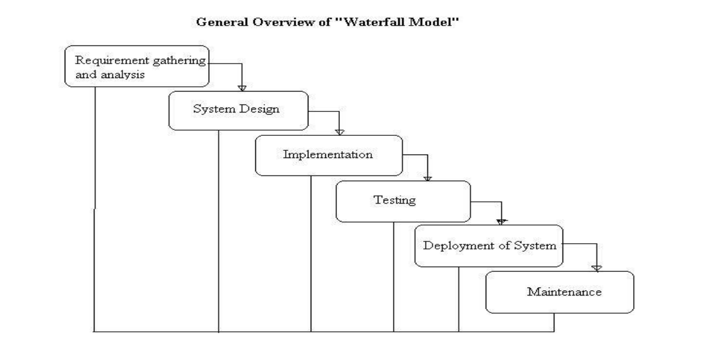

Fig. Waterfall model

**System design timeline:**

The system design procedure for the ST bus tracking system follows a structured approach to ensure the successful development and implementation of the application. The Gantt chart provided outlines the key tasks and their respective start and end dates. Let's explore the system design procedure based on the Gantt chart:

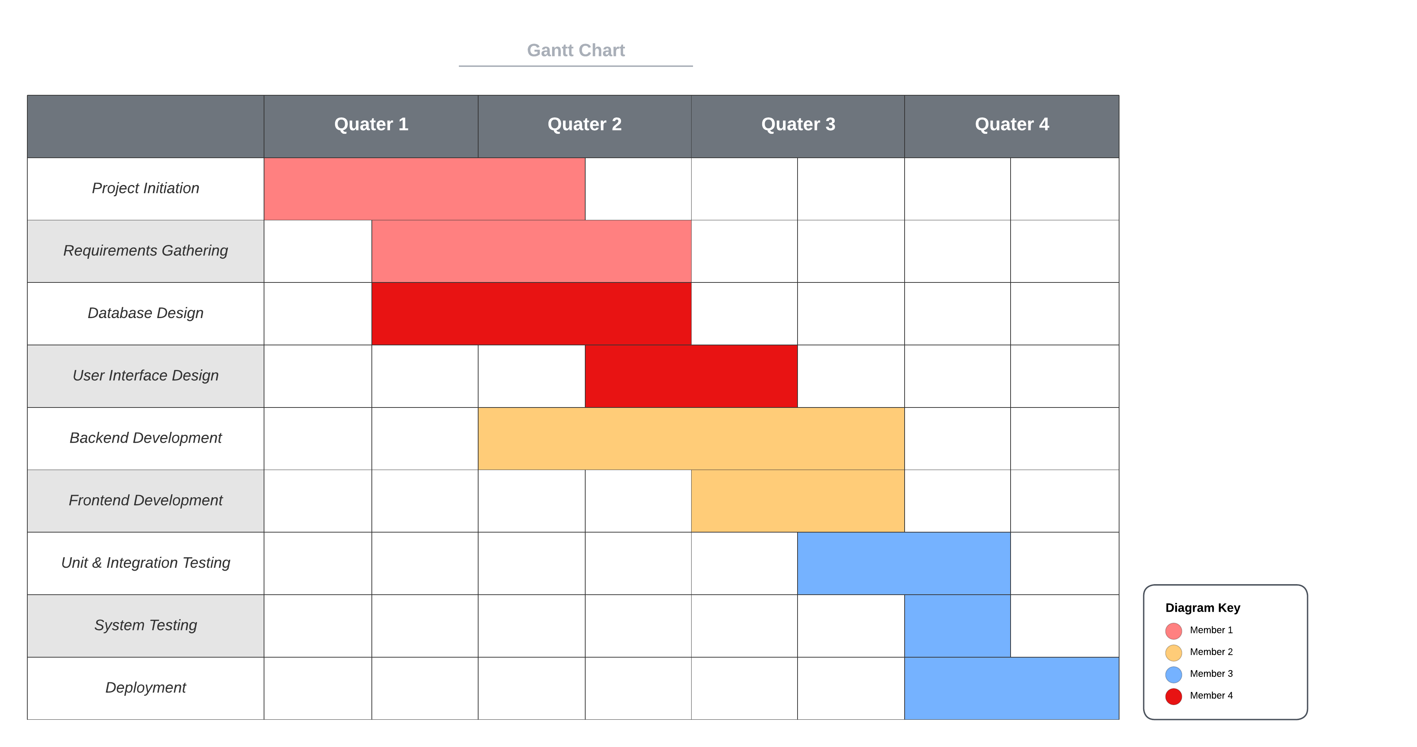Gantt Chart

1. Project Initiation:

- During this phase, the project is initiated, and the project team is formed.

- The project goals, objectives, and scope are defined.

- Stakeholder requirements are identified, and initial planning takes place.

2. Requirements Gathering :

- Detailed requirements are gathered from stakeholders, including users, administrators, and drivers.

- Use cases and functional requirements are documented.

- Non-functional requirements, such as performance, security, and scalability, are identified.

3. Database Design :

- The database schema is designed to store relevant data, such as user information, bus details, routes, and bus locations.

- Entity-relationship diagrams (ERDs) are created to model the relationships between different entities.

- Database tables, fields, and constraints are defined.

4. User Interface Design:

- The user interface (UI) design phase focuses on creating intuitive and user-friendly interfaces for the web application.

- Wireframes and mockups are created to visualize the layout and structure of the application.

- UI components, such as buttons, forms, and navigation menus, are designed to ensure a seamless user experience.

5. Backend Development:

- The backend development phase involves implementing the server-side logic and database integration.

- Node.js and Express.js are utilized to build the server application.

- APIs are developed to handle user authentication, bus tracking, and data retrieval from the database.

- Integration with external services, such as Google Maps API, may also be implemented.

6. Frontend Development :

- The frontend development phase focuses on implementing the user interface using HTML, CSS, and JavaScript.

- The UI components designed earlier are translated into code.

- Client-side interactions, such as bus search, real-time updates, and map integration, are implemented using jQuery and AJAX.

7. Integration and Testing:

- The integration phase involves combining the backend and frontend components to create a functional system.

- The system is thoroughly tested to ensure its functionality, reliability, and performance.

- Unit testing, integration testing, and user acceptance testing are conducted to identify and fix any issues.

8. Deployment and Launch:

- The application is deployed to a production environment, making it accessible to users.

- Server configurations and infrastructure are set up to support the application's operation.

- Final checks are performed to ensure all components are working correctly.

Databases play a crucial role in the functioning of the bus tracking system. In this particular system, PostgreSQL is used as the database management system. Let's explore databases and how PostgreSQL works for this system:

1. Databases:

- A database is a structured collection of data that is organized, stored, and managed for efficient retrieval and manipulation.

- Databases provide a way to store and retrieve data reliably, efficiently, and securely.

- They offer features such as data integrity, concurrency control, and data consistency.

2. PostgreSQL:

- PostgreSQL is a powerful and open-source relational database management system (RDBMS) that is widely used for web applications.

- It provides robust features and capabilities for storing, retrieving, and managing structured data.

- PostgreSQL supports various data types, including numeric, string, date/time, Boolean, and more.

- It offers advanced features such as transactions, views, triggers, stored procedures, and full-text search.

- PostgreSQL is known for its reliability, scalability, and extensibility.

3. Database Schema:

- The database schema defines the structure and organization of the database, including tables, columns, relationships, and constraints.

- In the bus tracking system, the database schema is designed to store information related to buses, drivers, users, routes, and bus locations.

- The schema includes tables such as "BusInfo," "DriverInfo," "UserInfo," "RouteInfo," "BusLocation," and others.

- Each table represents an entity or concept in the system, and the columns within the table represent specific attributes of that entity.

4. PostgreSQL Features in the System:

- Data Storage: PostgreSQL efficiently stores the bus-related data in tables within the database. For example, the "BusLocation" table stores the current location and other details of buses.

- Data Retrieval: PostgreSQL allows querying the database to retrieve specific information. The system can fetch bus locations based on parameters such as bus ID or route ID.

- Data Manipulation: PostgreSQL supports inserting, updating, and deleting data in the tables. This allows the system to modify bus information, driver details, and other relevant data as required.

- Relationships: PostgreSQL supports defining relationships between tables through foreign key constraints. For example, the "DriverInfo" table references the "BusInfo" table using a foreign key to assign a bus to a driver.

- Data Integrity: PostgreSQL enforces data integrity rules such as primary key constraints, unique constraints, and foreign key constraints to maintain the consistency and reliability of the data.

- Performance Optimization: PostgreSQL offers various techniques for optimizing database performance, such as indexing, query optimization, and caching strategies. These optimizations ensure efficient data retrieval and processing.

PostgreSQL serves as the underlying database management system for the bus tracking system, providing a reliable and scalable storage solution. It allows storing, retrieving, and manipulating bus-related data efficiently, ensuring data integrity and supporting the required system functionalities.

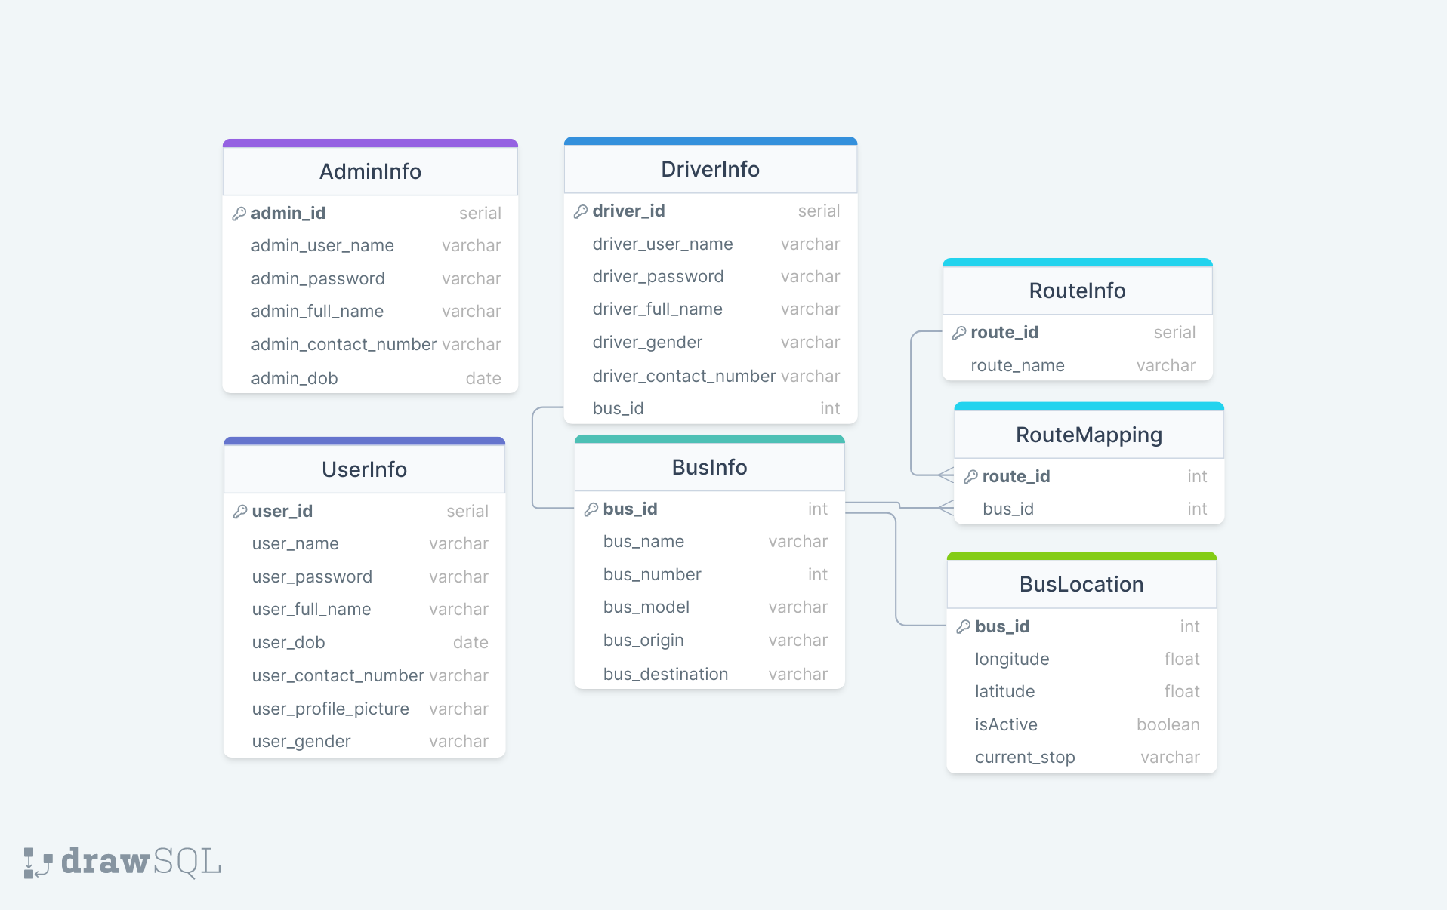Fig. Database Schema

**SQL Code:**

**CREATE** **TABLE** "BusLocation"("bus_id" INTEGER **NOT** **NULL**,  
 "longitude" DOUBLE **PRECISION** **NOT** **NULL**,  
 "latitude" DOUBLE **PRECISION** **NOT** **NULL**,  
 "isActive" BOOLEAN **NOT** **NULL**,  
 "current_stop" VARCHAR(**255**) **NOT** **NULL**  
);  
ALTER **TABLE**  
 "BusLocation" **ADD** **PRIMARY** **KEY**("bus_id");  
CREATE **TABLE** "DriverInfo"(  
 "driver_id" SERIAL **NOT** **NULL**,  
 "driver_user_name" VARCHAR(**255**) **NOT** **NULL**,  
 "driver_password" VARCHAR(**255**) **NOT** **NULL**,  
 "driver_full_name" VARCHAR(**255**) **NOT** **NULL**,  
 "driver_gender" VARCHAR(**255**) **NOT** **NULL**,  
 "driver_contact_number" VARCHAR(**255**) **NOT** **NULL**,  
 "bus_id" INTEGER **NOT** **NULL**  
);  
ALTER **TABLE**  
 "DriverInfo" **ADD** **PRIMARY** **KEY**("driver_id");  
CREATE **TABLE** "UserInfo"(  
 "user_id" SERIAL **NOT** **NULL**,  
 "user_name" VARCHAR(**255**) **NOT** **NULL**,  
 "user_password" VARCHAR(**255**) **NOT** **NULL**,  
 "user_full_name" VARCHAR(**255**) **NOT** **NULL**,  
 "user_dob" DATE **NOT** **NULL**,  
 "user_contact_number" VARCHAR(**255**) **NOT** **NULL**,  
 "user_profile_picture" VARCHAR(**255**) **NOT** **NULL**,  
 "user_gender" VARCHAR(**255**) **NOT** **NULL**  
);  
ALTER **TABLE**  
 "UserInfo" **ADD** **PRIMARY** **KEY**("user_id");  
CREATE **TABLE** "AdminInfo"(  
 "admin_id" SERIAL **NOT** **NULL**,  
 "admin_user_name" VARCHAR(**255**) **NOT** **NULL**,  
 "admin_password" VARCHAR(**255**) **NOT** **NULL**,  
 "admin_full_name" VARCHAR(**255**) **NOT** **NULL**,  
 "admin_contact_number" VARCHAR(**255**) **NOT** **NULL**,  
 "admin_dob" DATE **NOT** **NULL**  
);  
ALTER **TABLE**  
 "AdminInfo" **ADD** **PRIMARY** **KEY**("admin_id");  
CREATE **TABLE** "RouteInfo"(  
 "route_id" SERIAL **NOT** **NULL**,  
 "route_name" VARCHAR(**255**) **NOT** **NULL**);  
ALTER **TABLE**  
 "RouteInfo" **ADD** **PRIMARY** **KEY**("route_id");  
CREATE **TABLE** "RouteMapping"(  
 "route_id" INTEGER **NOT** **NULL**,  
 "bus_id" INTEGER **NOT** **NULL**  
);  
ALTER **TABLE**  
 "RouteMapping" **ADD** **PRIMARY** **KEY**("route_id");  
CREATE **TABLE** "BusInfo"(  
 "bus_id" INTEGER **NOT** **NULL**,  
 "bus_name" VARCHAR(**255**) **NOT** **NULL**,  
 "bus_number" INTEGER **NOT** **NULL**,  
 "bus_model" VARCHAR(**255**) **NOT** **NULL**,  
 "bus_origin" VARCHAR(**255**) **NOT** **NULL**,  
 "bus_destination" VARCHAR(**255**) **NOT** **NULL**  
);  
ALTER **TABLE**  
 "BusInfo" **ADD** **PRIMARY** **KEY**("bus_id");  
ALTER **TABLE**  
 "DriverInfo" **ADD** **CONSTRAINT** "driverinfo_bus_id_foreign" **FOREIGN** **KEY**("bus_id") **REFERENCES** "BusInfo"("bus_id");  
ALTER **TABLE**  
 "RouteMapping" **ADD** **CONSTRAINT** "routemapping_bus_id_foreign" **FOREIGN** **KEY**("bus_id") **REFERENCES** "BusInfo"("bus_id");  
ALTER **TABLE**  
 "BusLocation" **ADD** **CONSTRAINT** "buslocation_bus_id_foreign" **FOREIGN** **KEY**("bus_id") **REFERENCES** "BusInfo"("bus_id");  
ALTER **TABLE**  
 "RouteMapping" **ADD** **CONSTRAINT** "routemapping_route_id_foreign" **FOREIGN** **KEY**("route_id") **REFERENCES** "RouteInfo"("route_id");

**Modules Used**

1. User Module:

The user module in the ST bus tracking system plays a crucial role in providing a seamless experience for the users of the application. The user module enables users to register, login, and search for buses based on their destination. Users can view the list of buses following their desired route, access bus details, and track the bus's real-time location. Let's explore the different components and features of the user module in detail:

1. User Registration:

- Users can register for an account by providing their necessary details such as name, email address, and password.

- The registration process may involve email verification or account activation to ensure the authenticity of user accounts.

- Upon successful registration, users gain access to additional features and personalized settings.

2. User Login:

- Registered users can log in to their accounts using their credentials (email and password).

- The login process involves authentication to verify the user's identity and grant access to their account.

- Secure authentication mechanisms, such as encryption and hashing, are employed to protect user credentials.

3. User Dashboard:

- After logging in, users are presented with a personalized dashboard that provides an overview of their account and relevant information.

- The dashboard may display user-specific details, such as profile information, past bus searches, and saved preferences.

4. Bus Search:

- The user module allows users to search for buses based on their desired destination.

- Users can input their preferred destination in the search interface, and the system retrieves buses following that route.

- The search results may include details such as bus name, bus number, origin, destination, and current location.

5. Real-Time Bus Tracking:

- Users can access real-time information about buses, including their current location and route.

- By selecting a specific bus from the search results, users can view the bus's live location on an interactive map.

- Real-time updates are provided through integration with technologies like WebSockets or AJAX requests to ensure timely information.

6. Bus Details and Stops:

- Users can access detailed information about each bus, including its model, origin, destination, and major stops along the route.

- The system may display arrival and departure times for each stop to assist users in planning their travel accordingly.

The user module aims to provide a user-friendly and intuitive interface for users to interact with the ST bus tracking system. It empowers users with the ability to search for buses, track their real-time locations, access detailed bus information, and personalize their settings. By offering these features, the user module enhances the overall user experience and promotes user engagement with the application.

**User Flow Chart**

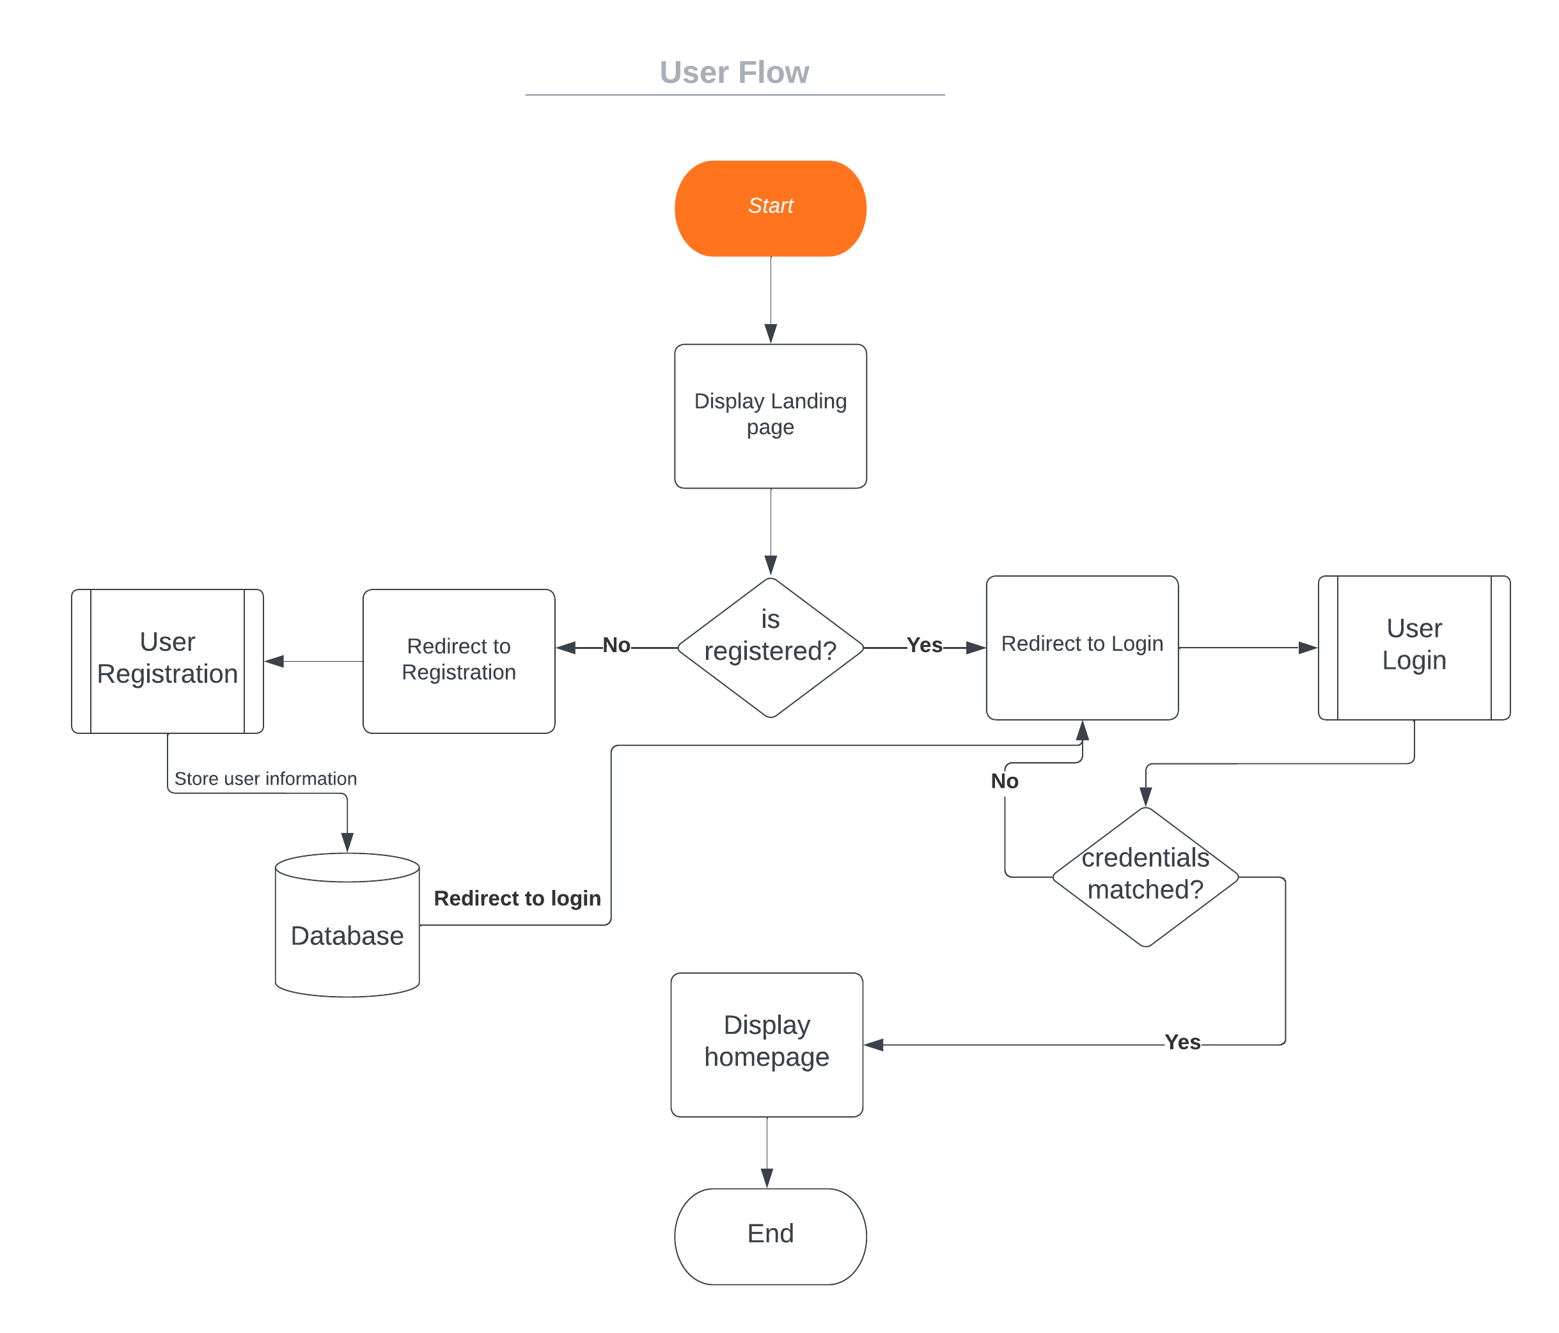

Fig. User Flow chart

The user flowchart illustrates the sequence of steps and interactions that a user goes through while using the ST bus tracking system. It provides a visual representation of the user journey within the web application. Here's an explanation of the user flowchart:

1. Start: The flowchart begins with the user accessing the ST bus tracking system through a web browser or a mobile application.

2. Registration: If the user is a new user, they have the option to register for an account. The flowchart depicts the decision point where the user can choose to register or proceed with login if they already have an account.

3. Login: The user enters their login credentials (username and password) to authenticate themselves within the system. The flowchart shows the verification process, where the system checks the entered credentials against the stored user information in the database.

4. User Dashboard: Upon successful login, the user is directed to their dashboard, which serves as the central hub for accessing various features and functionalities of the ST bus tracking system.

5. End: The flowchart concludes at the endpoint, representing the completion of the user flow within the ST bus tracking system.

The user flowchart provides a visual representation of the steps and decision points involved in the user's interaction with the web application. It helps in understanding the user experience, identifying potential bottlenecks or usability issues, and ensuring a smooth and intuitive journey for the users.

2. Driver Module:

The driver module in the ST bus tracking system is designed to cater to the needs of the bus drivers who are responsible for operating the buses and updating their status during the journey. This module includes functionalities that enable driver authentication, status updates, and communication with the system administrators. Let's delve into the key components and features of the driver module:

1. Driver Authentication:

- Drivers can log in to their accounts using the credentials provided by the system administrators.

- The login process involves verifying the driver's identity and ensuring that only authorized individuals have access to the driver module.

2. Driver Dashboard:

- Upon successful login, drivers are presented with a dedicated dashboard that provides an overview of their assigned bus and relevant information.

- The dashboard may display details such as the bus number, route information, and current status.

3. Driving Controls:

- The driver module includes driving controls that allow drivers to update their status during the journey.

- Common driving controls may include "Start Driving," "Stop Driving," "Arrived," and "In Traffic."

- By utilizing these controls, drivers can inform the system and passengers about the current status of the bus.

4. Status Updates:

- When a driver initiates a journey by clicking the "Start Driving" control, the system registers the bus as active and starts tracking its location in real-time.

- The driver can update the status to "Stop Driving" when the journey is complete or when the bus is temporarily halted.

- Additionally, the "Arrived" status can be selected when the bus reaches a specific destination or stop, indicating that passengers can disembark.

5. Real-Time Location Tracking:

- The driver module integrates with the bus tracking system to provide real-time location updates for the assigned bus.

- By utilizing location tracking technologies such as GPS or cellular networks, the system accurately tracks the bus's current location on the map.

- This real-time location data is crucial for displaying accurate bus positions to users and system administrators.

The driver module plays a vital role in the ST bus tracking system by empowering drivers with the necessary tools to update their status, communicate with administrators, and provide accurate location information. It enhances overall operational efficiency and enables effective coordination between drivers, system administrators, and passengers.

**Driver Flow Chart**

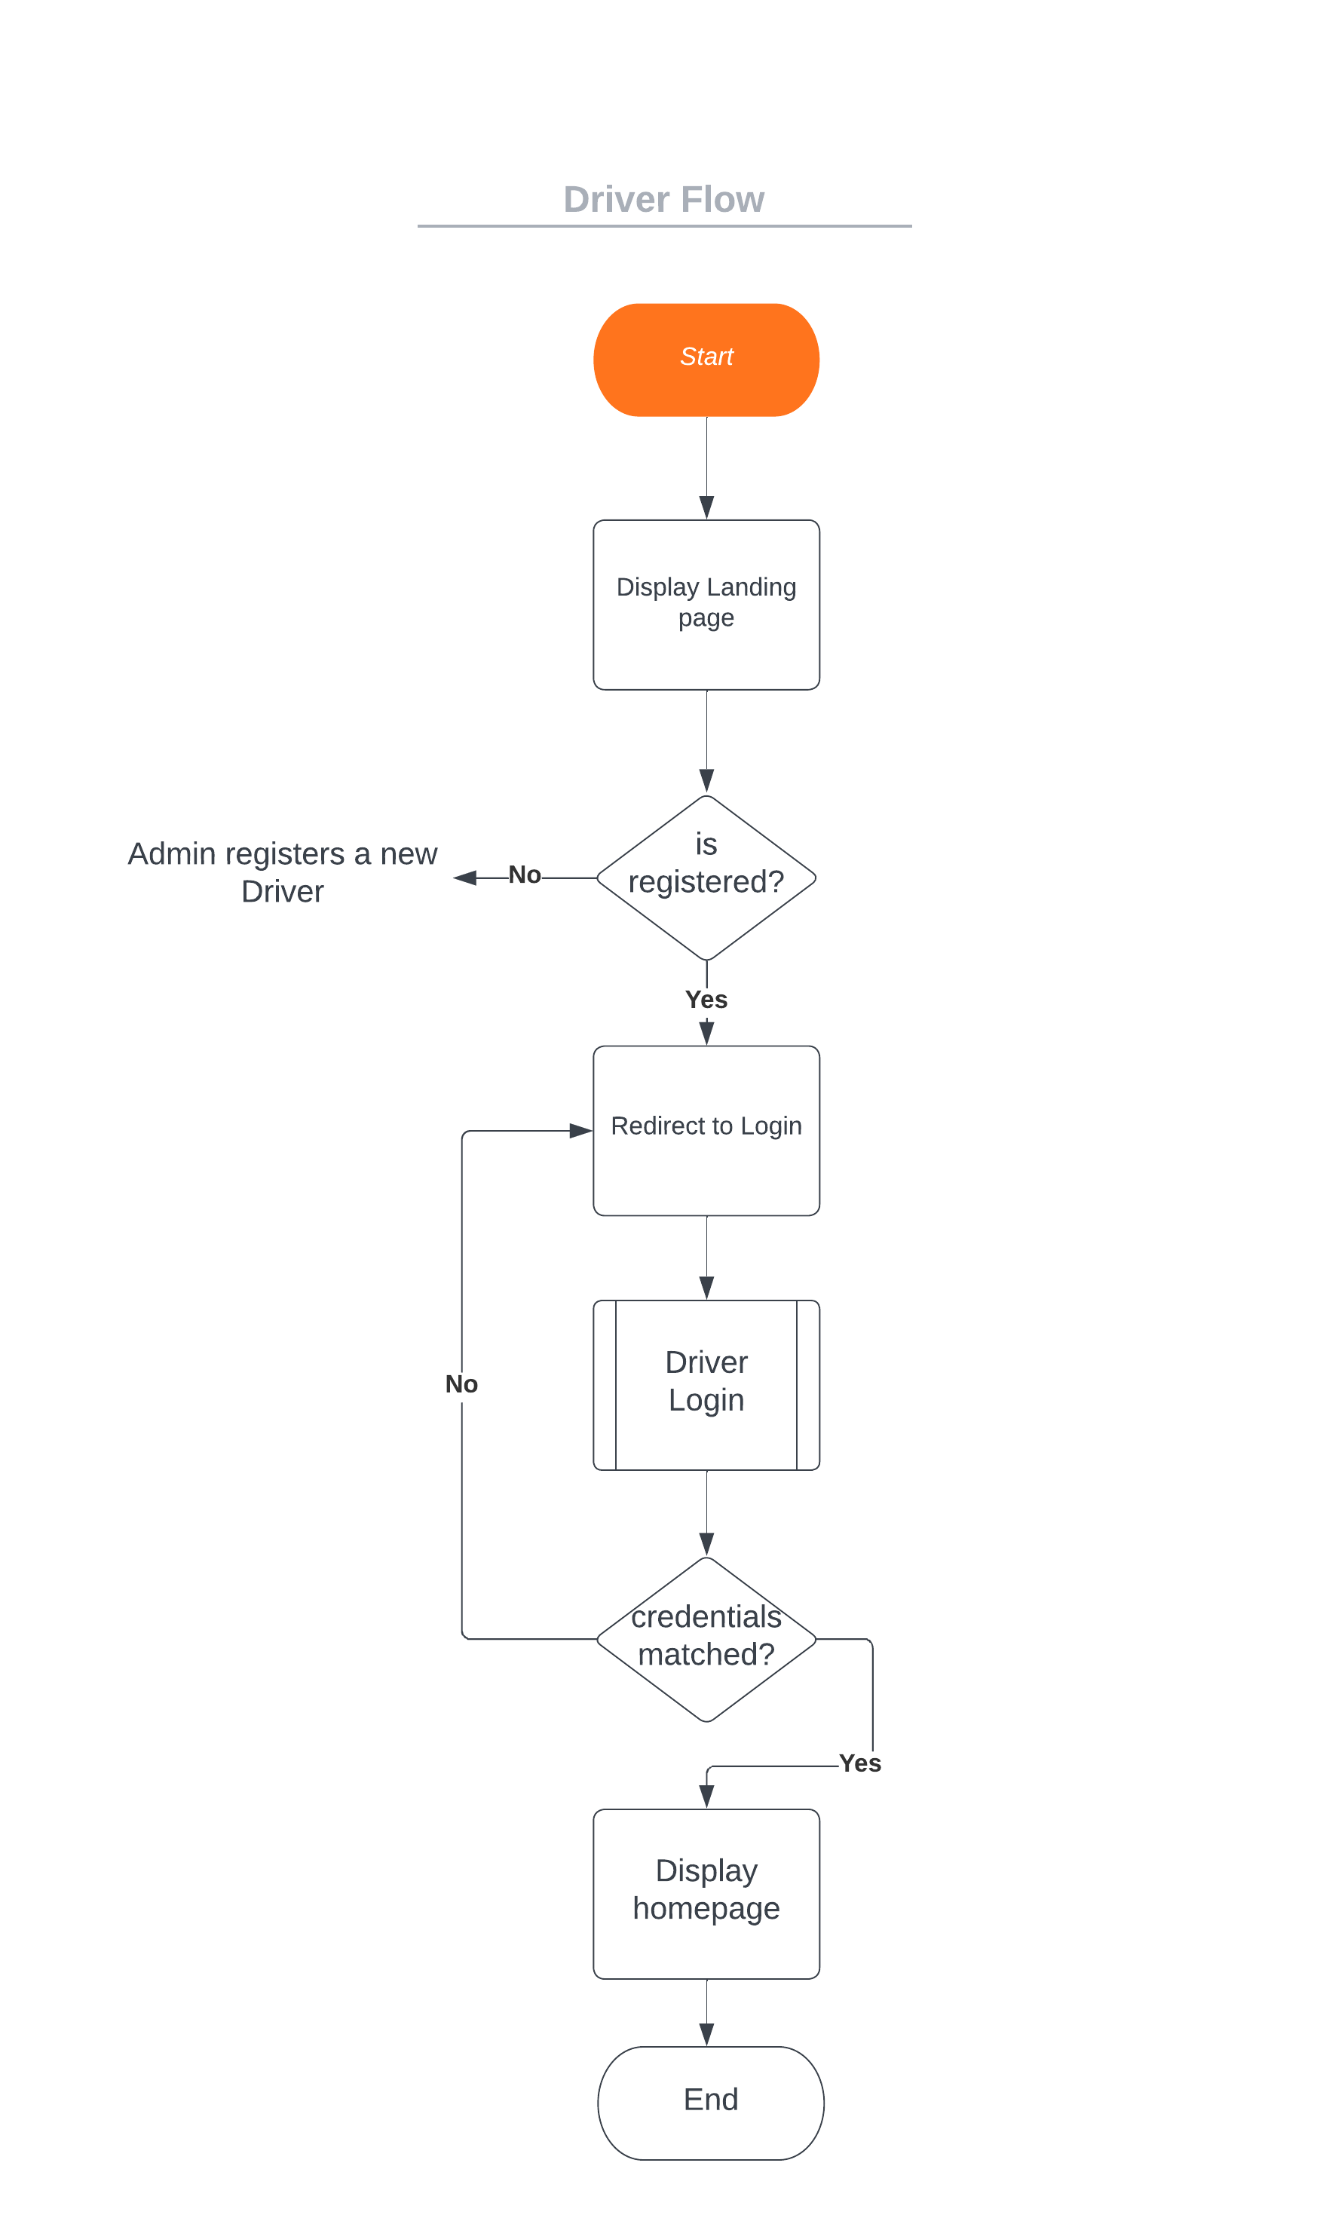

Fig. Driver Flow Chart

**Admin Module:**

The admin module offers comprehensive control over the system. It includes functionalities such as user management, driver management, bus management, and route management. Admins can view and delete user accounts, search for specific users, add/delete/update drivers, assign buses to drivers, and manage bus details, including adding/updating/deleting buses and defining routes.

The admin module in the ST bus tracking system provides administrators with comprehensive control and management capabilities. It allows admins to oversee and administer various aspects of the system. Here's an explanation of the main functionalities of the admin module:

1. User Management:

- View Users: The admin can view a list of all registered users in the system. This functionality provides an overview of the user base.

- Delete Users: The admin can delete user accounts if necessary. This functionality enables the admin to manage user data and maintain system integrity.

- Search Users: The admin can search for specific users based on criteria such as username or other user details. This functionality facilitates efficient user management.

2. Driver Management:

- Add Driver: The admin can add new drivers to the system. This functionality involves providing basic details of the driver, including their username, password, full name, contact number, and assigning them to a specific bus.

- Delete Driver: The admin can delete driver profiles from the system if needed. This functionality allows for managing driver records and making necessary adjustments.

- Update Driver: The admin can update driver information, such as contact number or personal details. This functionality ensures accurate and up-to-date driver records.

3. Bus Management:

- Add Bus: The admin can add new buses to the system. This functionality involves specifying details such as bus name, bus number, bus model, origin, and destination.

- Delete Bus: The admin can remove buses from the system. This functionality allows for managing the bus fleet and making necessary changes.

- Update Bus: The admin can update bus information, such as the bus number or destination. This functionality ensures accurate and up-to-date bus records.

4. Route Management:

- Add Route: The admin can add new routes to the system. This functionality involves defining the route name and specifying the stops along the route.

- Delete Route: The admin can delete routes from the system. This functionality allows for managing the available routes and making adjustments when needed.

5. Assign Driver to Bus:

- The admin can assign drivers to specific buses. This functionality ensures that each bus has an assigned driver responsible for its operation.

- The admin can only assign drivers to buses that are currently unassigned, ensuring that each driver is associated with a single bus at a time.

6. Manage Bus Locations:

- The admin can monitor and manage the real-time locations of buses in the system. This functionality involves receiving and updating the latitude, longitude, and current stop information of each bus.

- The admin can view the current location of buses on a map or in a list format, allowing for effective monitoring and tracking.

The admin module provides comprehensive control and management capabilities to ensure the smooth operation of the ST bus tracking system. It enables admins to manage users, drivers, buses, routes, and bus locations effectively. These functionalities empower admins to maintain the integrity of the system, make necessary updates, and ensure the efficient operation of the bus tracking services.

System Design Approaches:

The proposed system can be designed using a multi-tier architecture, separating the presentation layer, application logic layer, and data layer. This promotes modularity, scalability, and maintainability. The use of frameworks like Node.js and Express can facilitate rapid development, while PostgreSQL can serve as the database management system. Additionally, client-side technologies such as EJS, jQuery, and AJAX can be leveraged to enhance the user experience and provide dynamic updates.

UML Diagrams:

Several UML (Unified Modeling Language) diagrams can be created to depict the system's structure and behavior. Some essential diagrams include:

- Use Case Diagram: This diagram illustrates the interactions between different actors (users, admins, and drivers) and the system, showcasing the system's functionalities.

**Admin Use Case Diagram**

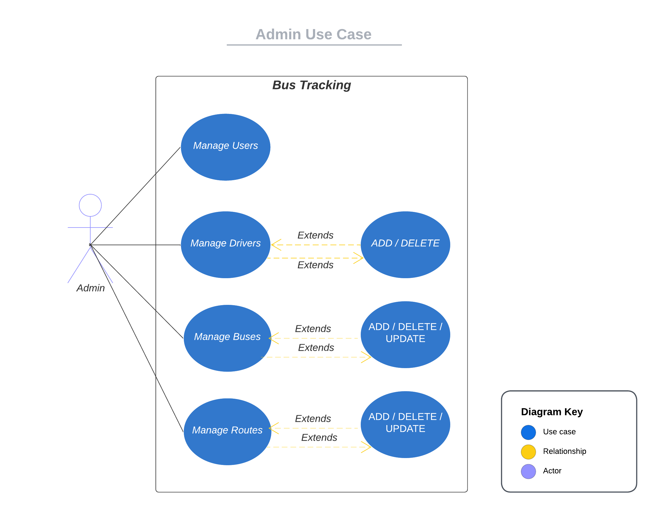

Sure! Here's a description of the use case diagram for the admin module in the ST bus tracking system:

The Admin Use Case Diagram represents the various interactions and functionalities available to the admin in the system. It illustrates the different use cases or actions that the admin can perform. Here are the main components of the Admin Use Case Diagram:

1. View Users: This use case allows the admin to view the list of registered users in the system. It provides an overview of the user base and their details.

2. Delete User: The admin can delete user accounts using this use case. It enables the admin to remove a user from the system if necessary.

3. Search Users: This use case enables the admin to search for specific users based on criteria such as username or other user details. It allows the admin to find and retrieve user information efficiently.

4. Add Driver: The admin can add a new driver to the system using this use case. It involves providing the necessary details of the driver, including username, password, full name, contact number, and assigning them to a specific bus.

5. Delete Driver: This use case allows the admin to delete a driver profile from the system. The admin can remove a driver if needed, managing driver records effectively.

6. Update Driver: The admin can update driver information, such as contact number or personal details, using this use case. It ensures that driver records are accurate and up-to-date.

7. Add Bus: The admin can add a new bus to the system using this use case. It involves specifying details such as bus name, bus number, bus model, origin, and destination.

8. Delete Bus: This use case enables the admin to delete a bus from the system. It allows the admin to manage the bus fleet and make necessary adjustments.

9. Update Bus: The admin can update bus information, such as the bus number or destination, using this use case. It ensures that bus records are accurate and up-to-date.

10. Add Route: This use case allows the admin to add a new route to the system. It involves defining the route name and specifying the stops along the route.

11. Delete Route: The admin can delete a route from the system using this use case. It allows for managing the available routes and making adjustments as needed.

12. Assign Driver to Bus: This use case enables the admin to assign drivers to specific buses. It ensures that each bus has an assigned driver responsible for its operation.

13. Manage Bus Locations: The admin can monitor and manage the real-time locations of buses in the system using this use case. It involves receiving and updating the latitude, longitude, and current stop information of each bus.

The Admin Use Case Diagram illustrates the various actions and functionalities available to the admin in the ST bus tracking system. It provides an overview of the interactions between the admin and the system, helping to understand the admin's role and the capabilities they possess.

By adopting these system design approaches, utilizing UML diagrams, and implementing the proposed components, the ST bus tracking system will provide an efficient and user-friendly solution for tracking and monitoring state transport buses in real time.

**Sequence Diagram - API Call for fetching location:**

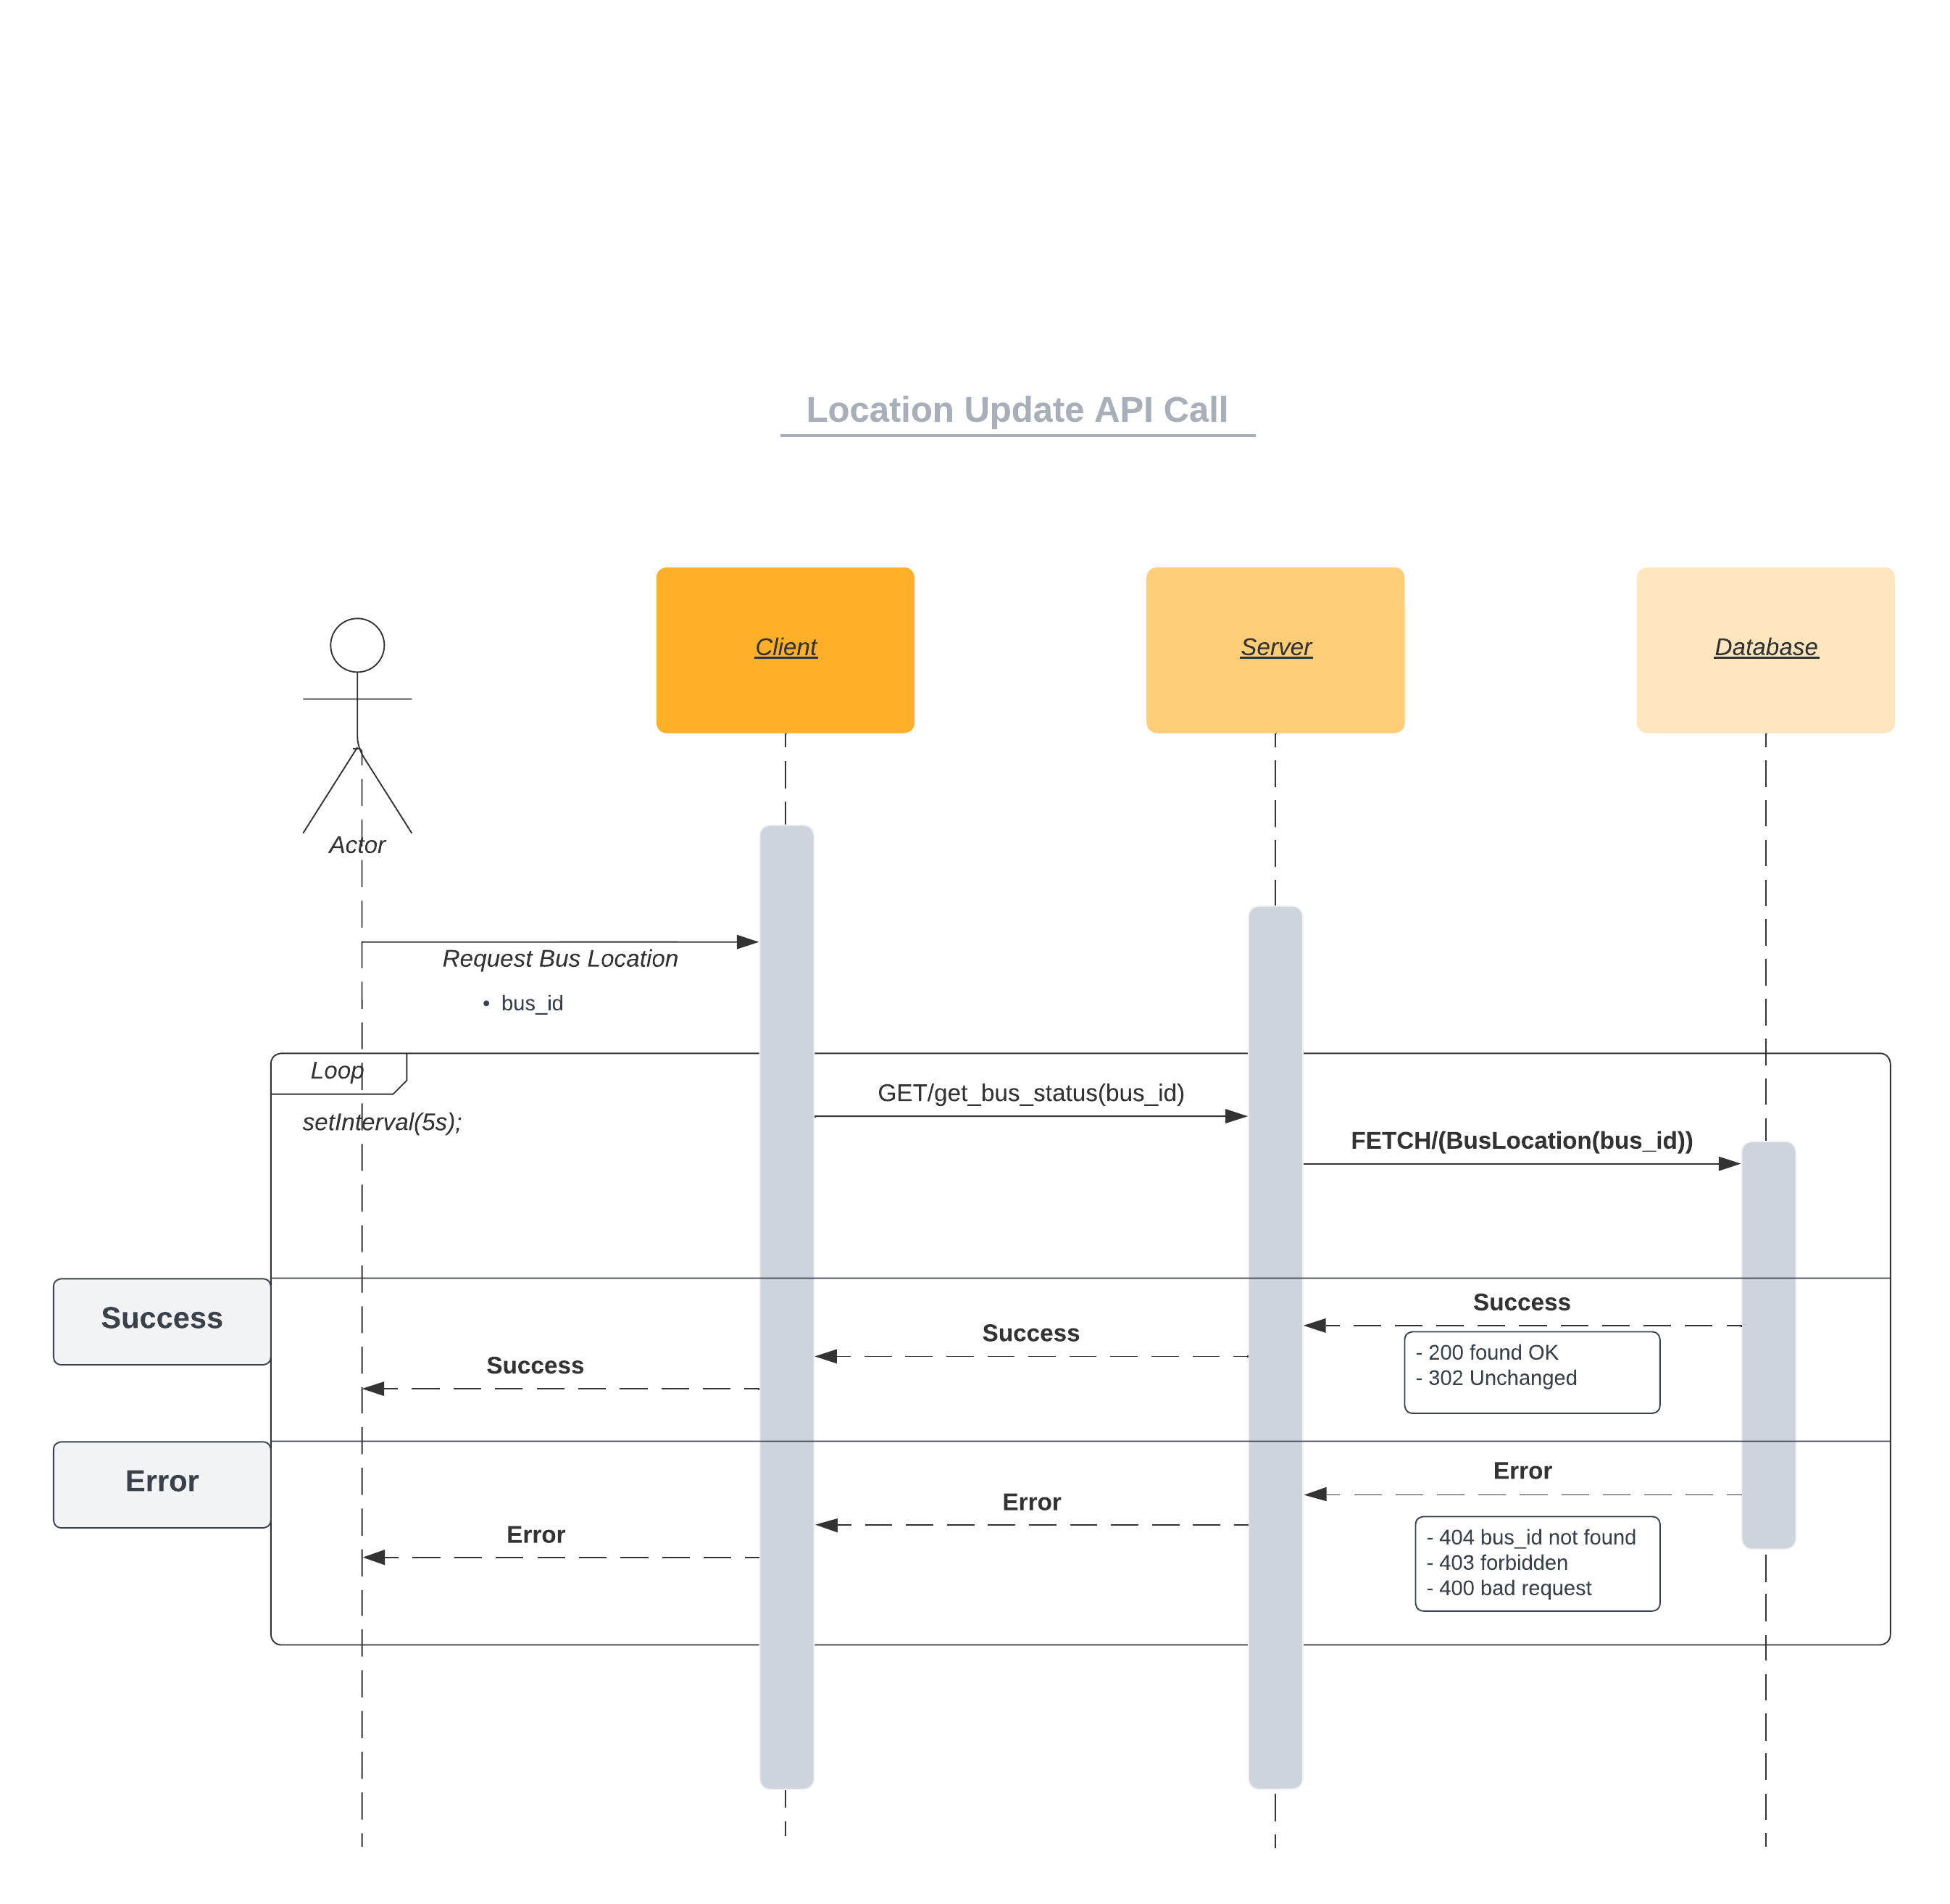

Fig. Sequence Diagram for Location API

To fetch the bus location from the server, the web application uses an API call. Here's an explanation of how the API call is made:

1. Client-Side Implementation:

- The client-side, which could be the user's browser, sends an HTTP request to the server to fetch the bus location data.

- This request is typically initiated when the user interacts with the web application, such as clicking on a bus or refreshing the map view.

- The client-side code, implemented using JavaScript/jQuery, handles the API call and processes the response received from the server.

2. Server-Side Implementation:

- On the server-side, the web application has a defined API endpoint to handle the request for fetching bus location data.

- This endpoint is typically implemented using a server-side framework such as Node.js with Express.

- The server receives the API request and processes it to retrieve the relevant data from the database.

- In this case, the server likely performs a database query to fetch the bus location information from the "BusLocation" table based on the provided parameters, such as the bus ID.

- The server then prepares the response containing the fetched bus location data.

3. API Call Flow:

- The client-side code constructs an HTTP request, specifying the URL of the API endpoint to be called. This URL could include additional parameters, such as the bus ID or any other required information.

- The client-side code uses the appropriate method, such as `$.ajax()` or `fetch()`, to send the API request to the server.

- The server receives the API request at the specified endpoint and processes it.

- The server-side code performs any necessary operations, such as querying the database, to fetch the bus location data.

- Once the server has retrieved the data, it prepares the response, typically in JSON format, and sends it back to the client.

- The client-side code receives the response from the server and handles it accordingly. It may update the map view or perform any other required actions based on the received data.

4. Authentication and Authorization:

- Depending on the implementation, the API call may require authentication and authorization to ensure that only authenticated users or authorized clients can access the bus location data.

- The client-side code includes any necessary authentication tokens or credentials in the API request headers.

- The server verifies the provided authentication information and ensures that the client has the necessary permissions to access the requested data.

Overall, the API call to fetch the bus location involves the client-side code initiating an HTTP request to the server's API endpoint, the server processing the request, retrieving the bus location data from the database, and sending the response back to the client. The client-side code then handles the response and updates the user interface accordingly.

**Networking and Sockets**

Socket programming is a fundamental concept in networking that enables communication between two or more devices over a network. It provides a mechanism for establishing connections, sending and receiving data, and managing network communication protocols. In the context of the bus tracking system, socket programming and networking play a crucial role in enabling real-time communication between the server, clients (users), and drivers.

1. Socket Programming:

- Sockets: A socket is an endpoint for communication between two machines over a network. It consists of an IP address and a port number.

- Server Socket: The server socket waits for incoming connections from clients. It listens to a specific port and accepts client connections when requested.

- Client Socket: The client socket initiates a connection to the server socket using the server's IP address and port number.

2. Networking:

- IP Address: An IP (Internet Protocol) address uniquely identifies a device on a network. It can be either IPv4 (32-bit) or IPv6 (128-bit) format.

- Port Number: A port number is a unique identifier that allows multiple applications on a single device to establish network connections. It helps in distinguishing different services or processes running on a device.

- TCP/IP Protocol: The Transmission Control Protocol/Internet Protocol (TCP/IP) is a suite of communication protocols used for transmitting data across networks. It provides reliable, connection-oriented communication between devices.

- HTTP/HTTPS: The Hypertext Transfer Protocol (HTTP) is a protocol used for transmitting data over the internet. It defines how clients and servers communicate and exchange information. HTTPS is a secure version of HTTP that uses encryption for secure data transmission.

3. Implementation in the Bus Tracking System:

- Real-time Communication: Socket programming enables real-time communication between the server and clients/drivers in the bus tracking system.

- WebSockets: WebSockets are a protocol that provides full-duplex communication channels over a single TCP connection. They allow the server to send data to the clients and vice versa in real time.

- Client-Server Interaction: Clients (users) make HTTP/HTTPS requests to the server to fetch bus locations and other relevant data. The server responds with the requested information, which is then displayed on the client-side.

- Driver Updates: Drivers use the driver module to update their status and location. The client-side application establishes a WebSocket connection with the server, enabling bi-directional communication. The server receives driver updates and broadcasts them to the relevant clients, ensuring real-time updates on the bus location.

- Socket.IO: Socket.IO is a library that simplifies real-time communication between the server and clients. It provides a WebSocket-like API and fallback mechanisms for browsers that do not support WebSockets.

In the bus tracking system, socket programming and networking are used to establish connections, exchange data, and provide real-time updates to clients. The server utilizes sockets and protocols like HTTP/HTTPS and WebSockets to handle client requests, track bus locations, and facilitate communication between the server, clients, and drivers. This enables users to view real-time bus locations, driver updates, and other relevant information through the web application.

Code Example:

// Import required modules  
const { Pool } = require('pg');  
const WebSocket = require('ws');  
  
// Create a PostgreSQL connection pool  
const pool = **new** Pool({  
 user: 'your_username',  
 password: 'your_password',  
 host: 'localhost',  
 port: **5432**,  
 database: 'your_database_name',  
});  
  
// Create a WebSocket server  
const wss = **new** WebSocket.Server({ port: **8080** });  
  
// Handle WebSocket connections  
wss.on('connection', (ws) => {  
 // Handle incoming WebSocket messages  
 ws.on('message', (message) => {  
 // Parse the received message  
 **const** { busId, latitude, longitude } = JSON.parse(message);  
  
 // Save the location data to the database  
 saveLocation(busId, latitude, longitude)  
 .then(() => {  
 // Broadcast the location update to all connected clients  
 broadcastLocation(busId, latitude, longitude);  
 })  
 .**catch**((error) => {  
 console.error('Error saving location:', error);  
 });  
 });  
});  
  
// Function to save location data to the database  
async **function** saveLocation(busId, latitude, longitude) {  
 **try** {  
 **const** client = await pool.connect();  
 **const** query = `  
 INSERT INTO BusLocation (bus_id, latitude, longitude)  
 VALUES ($1, $2, $3)  
 ON CONFLICT (bus_id)  
 DO UPDATE SET latitude = $2, longitude = $3;  
 `;  
 **const** values = [busId, latitude, longitude];  
 await client.query(query, values);  
 client.release();  
 } **catch** (error) {  
 **throw** error;  
 }  
}  
  
// Function to broadcast location update to all connected clients  
function broadcastLocation(busId, latitude, longitude) {  
 **const** message = JSON.stringify({ busId, latitude, longitude });  
  
 wss.clients.forEach((client) => {  
 **if** (client.readyState === WebSocket.OPEN) {  
 client.send(message);  
 }  
 });  
}

**Project Source Code**

Hi buddy

**App.js**

**const** express = require('express')  
const bodyParser = require("body-parser");  
const session = require('express-session');  
  
  
const app = express();  
  
app.set('view engine', 'ejs');  
  
app.use(bodyParser.urlencoded({ extended: **true** }));  
app.use('/static', express.**static**("public"));  
const oneDay = **1000** * **60** * **60** * **24**;  
  
app.use(session({  
 secret: "thisisanappsecretkeyforthebustrackingsystem",  
 saveUninitialized: **false**,  
 cookie: { maxAge: oneDay },  
 resave: **false**,  
}));  
  
// import routes  
const adminRouter = require('./routes/admin')  
const driverRouter = require('./routes/driver')  
const userRouter = require('./routes/user')  
const apiRouter = require('./routes/api')  
  
  
app.get('/', (req, res) => {  
 **if** (req.session.isAdminAuthenticated) {  
 res.redirect('/admin');  
 } **else** **if** (req.session.isDriverAuthenticated) {  
 res.redirect('/driver');  
 } **else** **if** (req.session.isUserAuthenticated) {  
 res.redirect('/user');  
 } **else** {  
 res.render("home");  
 }  
})  
  
app.use('/api', apiRouter);  
app.use('/admin', adminRouter);  
app.use('/driver', driverRouter);  
app.use('/user', userRouter);  
  
  
app.get('/logout', (req, res) => {  
 req.session.destroy(**function** (error) {  
 **if** (error) {  
 console.log("Unable to logout!", error);  
 } **else** {  
 res.redirect('/')  
 }  
 })  
})  
  
  
  
app.listen(**3000**, (error) => {  
 **if** (error) console.log("Error has occured", error);  
 **else** console.log("Server is running on port 3000");  
});

**Routes/admin.js**

**const** express = require('express');  
const router = express.Router();  
require('dotenv').config();  
  
// Serve static files  
router.use(express.**static**("public"));  
  
// DB Connection  
const pool = require('../modules/db');  
  
// Module for DB Operations  
const adminModule = require('../modules/admin')  
  
// Middleware for login authorization  
const { checkAdminLoginMiddleware } = require('../middleware/loginCheck')  
  
// Admin Login route  
router.route('/login')  
 .get(async (req, res) => {  
 **if** (req.session.isAdminAuthenticated) {  
 res.redirect('/')  
 }  
 **else** {  
 res.render("logins/adminLogin");  
 }  
 }).post(async (req, res) => {  
 **const** username = req.body.username;  
 **const** password = req.body.password;  
  
 **const** query = {  
 text: `SELECT * FROM AdminInfo WHERE admin_user_name = $1 AND admin_password = $2`,  
 values: [username, password]  
 }  
  
 **const** { rows } = await pool.query(query);  
  
 **if** (rows.length == **1**) {  
 req.session.isAdminAuthenticated = **true**;  
 req.session.adminId = rows[**0**].admin_id;  
 req.session.adminFullName = rows[**0**].admin_full_name;  
 req.session.usertype = 'Admin'  
  
 res.send({ success: **true** });  
 }  
 **else** res.send({ success: **false** });  
 });  
  
// Admin Home Route  
router.route('/')  
 .get(checkAdminLoginMiddleware, async (req, res) => {  
 **let** adminId = req.session.adminId;  
 **let** adminData = await adminModule.getAdminDataById(adminId);  
  
 res.render('admin/home', { adminData: adminData });  
 });  
  
// Users routes  
router.route('/users')  
 .get(checkAdminLoginMiddleware, async (req, res) => {  
 **const** userData = await adminModule.getAllUserData();  
 res.render('admin/users', { userData: userData });  
 })  
 .**delete**(checkAdminLoginMiddleware, async (req, res) => {  
 **const** { userId } = req.body;  
 **const** deleteStatus = await adminModule.deleteUserById(userId);  
 res.send({ statusCode: deleteStatus });  
 });  
  
// Admins routes  
router.route('/admins')  
 .get(checkAdminLoginMiddleware, async (req, res) => {  
 **const** adminData = await adminModule.getAllAdminData();  
 res.render('admin/admins', { adminData: adminData });  
 })  
 .post(async (req, res) => {  
 **let** username = req.body.username;  
 **let** password = req.body.password;  
 **let** fullname = req.body.fullname;  
 **let** phone = req.body.phone;  
 **let** dob = req.body.dob;  
  
 **let** adminAddStatus = await adminModule.addNewAdmin(username, password, fullname, phone, dob);  
 res.send({ statusCode: adminAddStatus });  
 })  
 .**delete**(async (req, res) => {  
 **const** { adminId } = req.body;  
 **const** deleteStatus = await adminModule.deleteAdminById(adminId);  
 res.send({ statusCode: deleteStatus })  
 });  
  
// Driver routes  
router.route('/drivers')  
 .get(checkAdminLoginMiddleware, async (req, res) => {  
 **const** driverData = await adminModule.getAllDriverData();  
 **const** busData = await adminModule.getAllUnassignedBusData();  
 res.render('admin/drivers', { driverData: driverData, busData: busData });  
 })  
 .post(async (req, res) => {  
 **const** { driverUserName, driverPassword, driverFullName, driverGender, busId, driverPhone } = req.body;  
 **const** driverAddStatuts = await adminModule.addNewDriver(driverUserName, driverPassword, driverFullName, driverGender, driverPhone, busId);  
 res.send({ statusCode: driverAddStatuts });  
 })  
 .put(async (req, res) => {  
 **const** { updatedBusId, driverId } = req.body;  
 **const** updateStatus = await adminModule.updateDriverBusDetails(updatedBusId, driverId);  
 res.send({ statusCode: updateStatus });  
 })  
 .**delete**(async (req, res) => {  
 **const** { driverId } = req.body;  
 **const** deleteStatus = await adminModule.deleteDriverById(driverId);  
 res.send({ statusCode: deleteStatus });  
 });  
  
// Bus routes  
router.route('/bus')  
 .get(checkAdminLoginMiddleware, async (req, res) => {  
 **const** busData = await adminModule.getAllBusData();  
 **const** routesList = await adminModule.getAllRouteData();  
 res.render('admin/bus', { busData: busData, routesList: routesList });  
 })  
 .post(async (req, res) => {  
 **const** { busName, busNumber, busModel, busOrigin, busDestination } = req.body;  
 **const** addBusStatus = await adminModule.addNewBus(busName, busNumber, busModel, busOrigin, busDestination);  
 res.send({ statusCode: addBusStatus });  
 })  
 .**delete**(async (req, res) => {  
 **const** { busId } = req.body;  
 **const** deleteStatus = await adminModule.deleteBusById(busId);  
 res.send({ statusCode: deleteStatus });  
 })  
 .put(async (req, res) => {  
 **const** { routesArray, arrivalTimeArray, busId } = req.body;  
 **const** updateBusStatus = await adminModule.updateBusStops(routesArray, arrivalTimeArray, busId);  
 res.send({ statusCode: updateBusStatus });  
 });  
  
// Live status route  
router.route('/live-status')  
 .get(checkAdminLoginMiddleware, async (req, res) => {  
 **const** busDetails = await adminModule.getLiveBusDetails();  
 res.render('components/map', { busDetails: busDetails });  
 });  
  
// Get live status API route  
router.route('/get-live-status')  
 .get(checkAdminLoginMiddleware, async (req, res) => {  
 **try** {  
 **const** liveBusData = await adminModule.getLiveData();  
 **const** busDetails = await adminModule.getLiveBusDetails();  
  
 // Create an array to store bus location data  
 **var** busLocations = [];  
  
 // Loop through the live bus data and extract relevant information  
 liveBusData.forEach(**function** (busData) {  
 **var** busLocation = {  
 busId: busData.bus_id,  
 lat: busData.latitude,  
 lng: busData.longitude,  
 isActive: busData.isactive  
 };  
  
 // Add the bus location to the array  
 busLocations.push(busLocation);  
 });  
  
 // Combine bus locations and bus details into a single object or array  
 **var** responseData = {  
 busLocations: busLocations,  
 busDetails: busDetails  
 };  
  
 // Send the combined data as a JSON response  
 res.json(responseData);  
 } **catch** (error) {  
 console.error('Error retrieving live bus status:', error);  
 res.status(**500**).send('Internal Server Error');  
 }  
 });  
  
// Routes routes  
router.route('/routes')  
 .get(checkAdminLoginMiddleware, async (req, res) => {  
 **const** routeData = await adminModule.getAllRouteData();  
 res.render('admin/routes', { routeData: routeData })  
 })  
 .post(async (req, res) => {  
 **const** { routeName } = req.body;  
 **const** addRouteResult = await adminModule.addNewRoute(routeName);  
 res.send({ statusCode: addRouteResult });  
 })  
 .**delete**(async (req, res) => {  
 **const** { itemId } = req.body;  
 **const** deleteStatus = await adminModule.deleteRouteById(itemId);  
 res.send({ statusCode: **0** });  
 });  
  
module.exports = router;

Views/admin/home.ejs

<%- include('../partials/commonheader') -%>  
  
 <%- include('navigation') -%>  
  
 <!-- admin-home.ejs -->  
 <div class="bg"></div>  
  
  
 <div class="container mt-5">  
  
 <div class="alert alert-primary" role="alert">  
 <h1 class="text-center"> Welcome, <%= adminData.admin_full_name %>  
 </h1>  
 <hr>  
 </div>  
  
 <div class="jumbotron">  
 <h1>Bus Tracking System</h1>  
 <p>Track your buses in real-time and enjoy convenient and efficient transportation.</p>  
  
 <h2>Features:</h2>  
 <ul>  
 <li><strong>Real-Time Bus Tracking:</strong> Keep an eye on the exact location of your bus in  
 real-time.</li>  
 <li><strong>Live Updates:</strong> Receive live updates about delays, diversions, and other  
 important information.</li>  
 <li><strong>Route Maps:</strong> Access detailed route maps to plan your journey more effectively.  
 </li>  
 <li><strong>User-Friendly Interface:</strong> Enjoy an intuitive and easy-to-use interface for  
 seamless navigation and interaction.</li>  
 <li><strong>Multi-Platform Support:</strong> Access the bus tracking system from your smartphone,  
 tablet, or computer.</li>  
 </ul>  
  
 <p>With our bus tracking system, you can make your daily commute more efficient and plan your journey  
 with confidence. Experience the convenience and reliability of our advanced tracking technology  
 today!</p>  
 </div>  
  
 <div class="row">  
 <div class="col-md-4 mb-4">  
 <div class="card">  
 <div class="card-body">  
 <h5 class="card-header">Profile</h5>  
 <div class="text-center mb-3">  
 <img src="/static/images/male.jpeg" alt="" class="rounded-circle m-2"  
 style="width: 150px; height: 150px;">  
 </div>  
 <table class="table table-responsive">  
 <tbody>  
 <tr>  
 <th scope="row">Full Name</th>  
 <td>  
 <%= adminData.admin_full_name %>  
 </td>  
 </tr>  
 <tr>  
 <th scope="row">Username</th>  
 <td>  
 <%= adminData.admin_user_name %>  
 </td>  
 </tr>  
 <tr>  
 <th scope="row">Contact Number</th>  
 <td>  
 <%= adminData.admin_contact_number %>  
 </td>  
 </tr>  
 <tr>  
 <th scope="row">Date of Birth</th>  
 <td>  
 <%= new Date(adminData.admin_dob).toDateString() %>  
 </td>  
 </tr>  
 </tbody>  
 </table>  
 </div>  
 </div>  
 </div>  
  
 <div class="col-md-8">  
 <div class="card">  
 <div class="card-body">  
 <h5 class="card-header">Options</h5>  
 <p class="card-title">List of available options</p>  
 <!-- Add a list of options the admin can do -->  
 <ul class="list-group">  
 <li class="list-group-item"><a href="/admin/admins">Manage Other Admins</a></li>  
 <li class="list-group-item"><a href="/admin/drivers">Manage Drivers</a></li>  
 <li class="list-group-item"><a href="/admin/bus">Manage Buses</a></li>  
 <li class="list-group-item"> <a href="/admin/users">View Users</a></li>  
 <li class="list-group-item"><a href="/api/live-status">View Live Status</a></li>  
 <!-- Add more options as needed -->  
 </ul>  
 </div>  
 </div>  
 </div>  
 </div>  
 </div>

**Result**

The result of the project is a location tracking system for buses that allows users to track the real-time location of buses on a map. The system consists of a web application that provides different functionalities for administrators and users.

For administrators, the system provides the following functionalities:

- Admin login: Administrators can log in to the system using their username and password.

- Dashboard: Once logged in, administrators are directed to a dashboard where they can view their account information and access various features.

- User Management: Administrators can view and manage user information, including adding new users and deleting existing users.

- Admin Management: Administrators can view and manage admin accounts, including adding new admins and deleting existing admins.

- Driver Management: Administrators can view and manage driver information, assign drivers to buses, and delete drivers.

- Bus Management: Administrators can view and manage bus information, add new buses, delete buses, and update bus stops.

- Route Management: Administrators can view and manage routes, add new routes, and delete existing routes.

- Live Bus Status: Administrators can view the live status of buses on a map, including their current location.

For users, the system provides the following functionalities:

- User Registration: Users can register for an account by providing their details.

- User Login: Registered users can log in to the system using their username and password.

- Bus Tracking: Once logged in, users can track the real-time location of buses on a map.

- Route Information: Users can access information about bus routes, including the origin, destination, and stops along the route.

The result of the project is a functional web application that enables administrators to manage bus, driver, and user information, while users can track buses and access route information. The system utilizes technologies such as Express.js, PostgreSQL, socket programming, and APIs to fetch and display real-time bus location data. It provides a user-friendly interface and reliable functionality for efficient bus tracking and management.

**Project Snapshots**

* **Home**
* 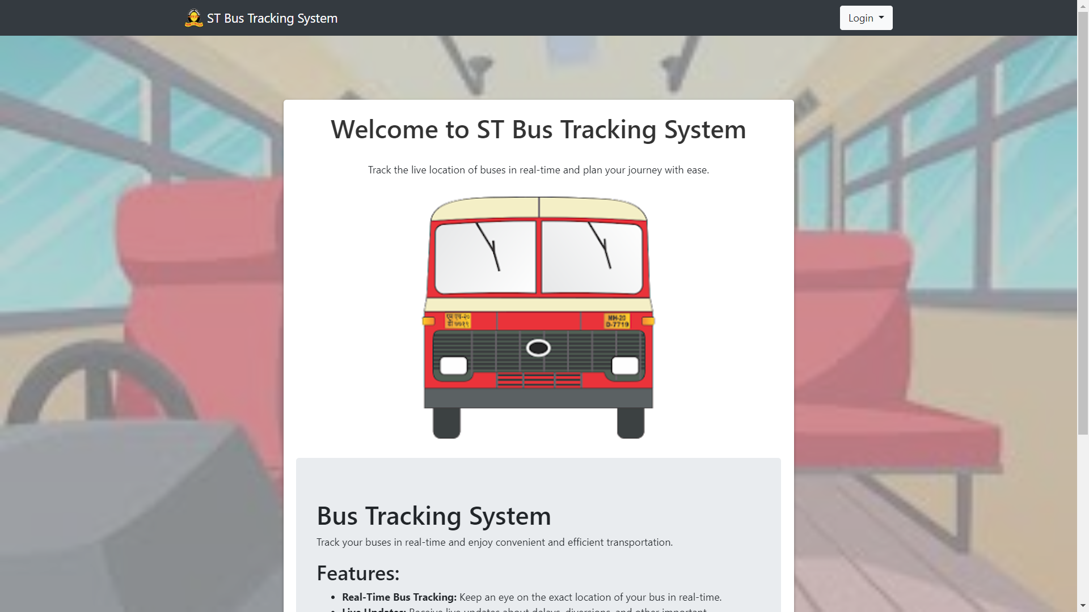
* **Admin**
* 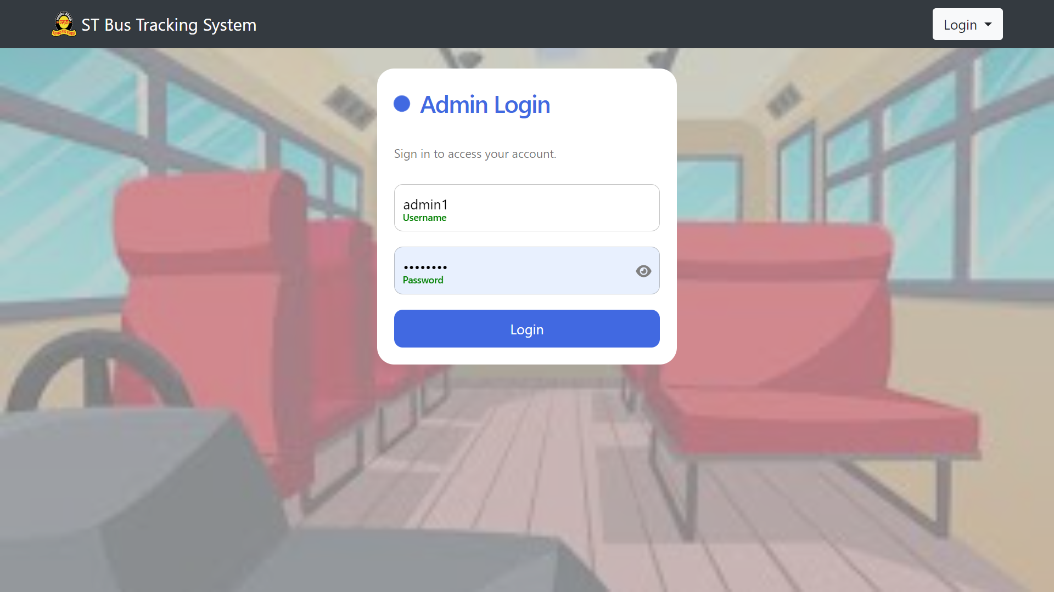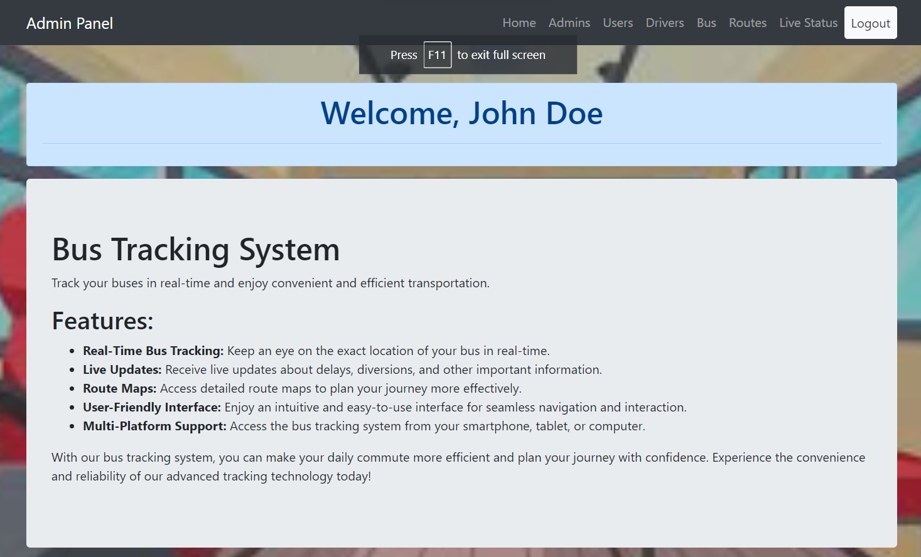
* 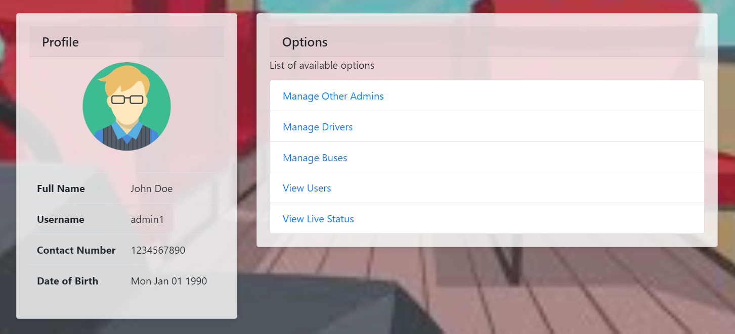
* 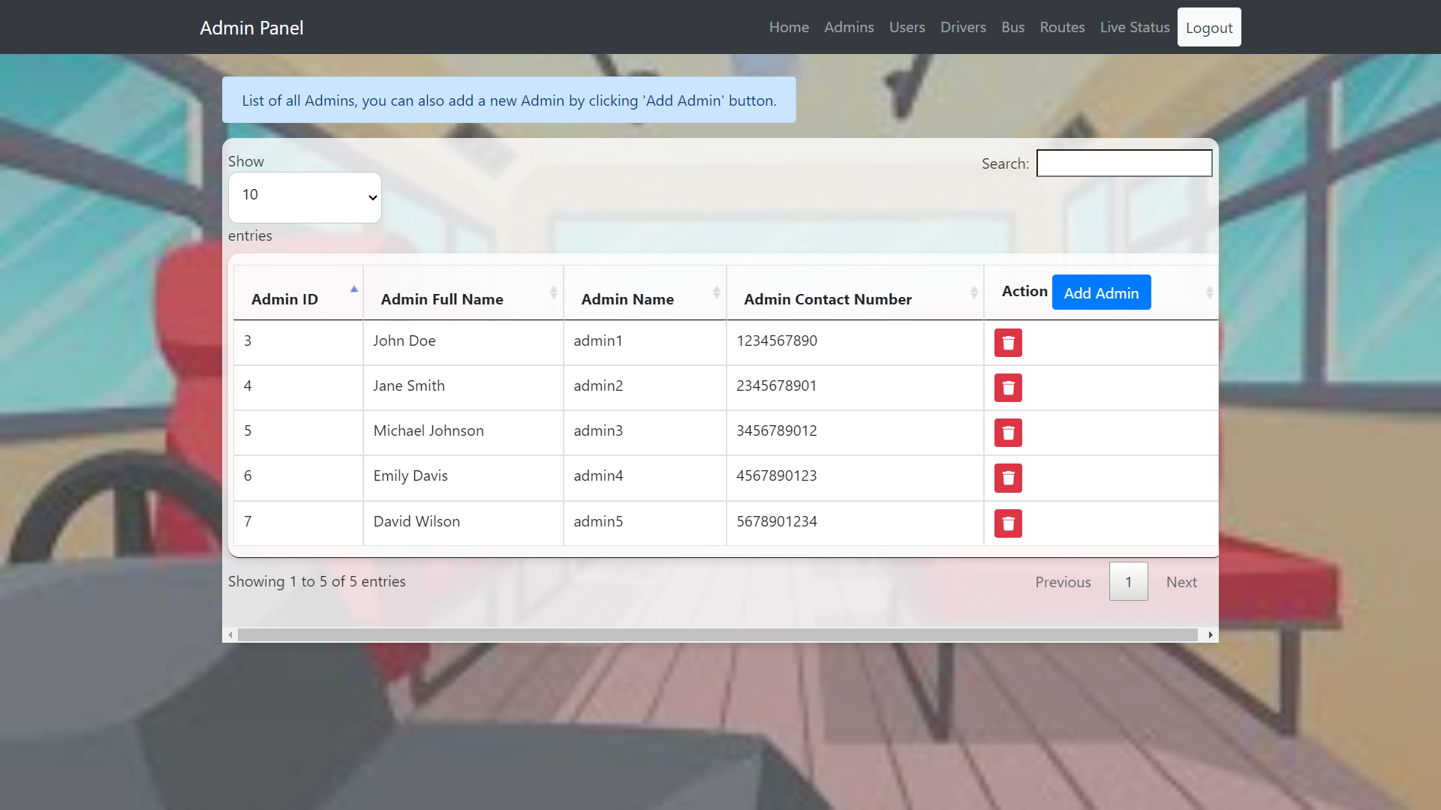
* 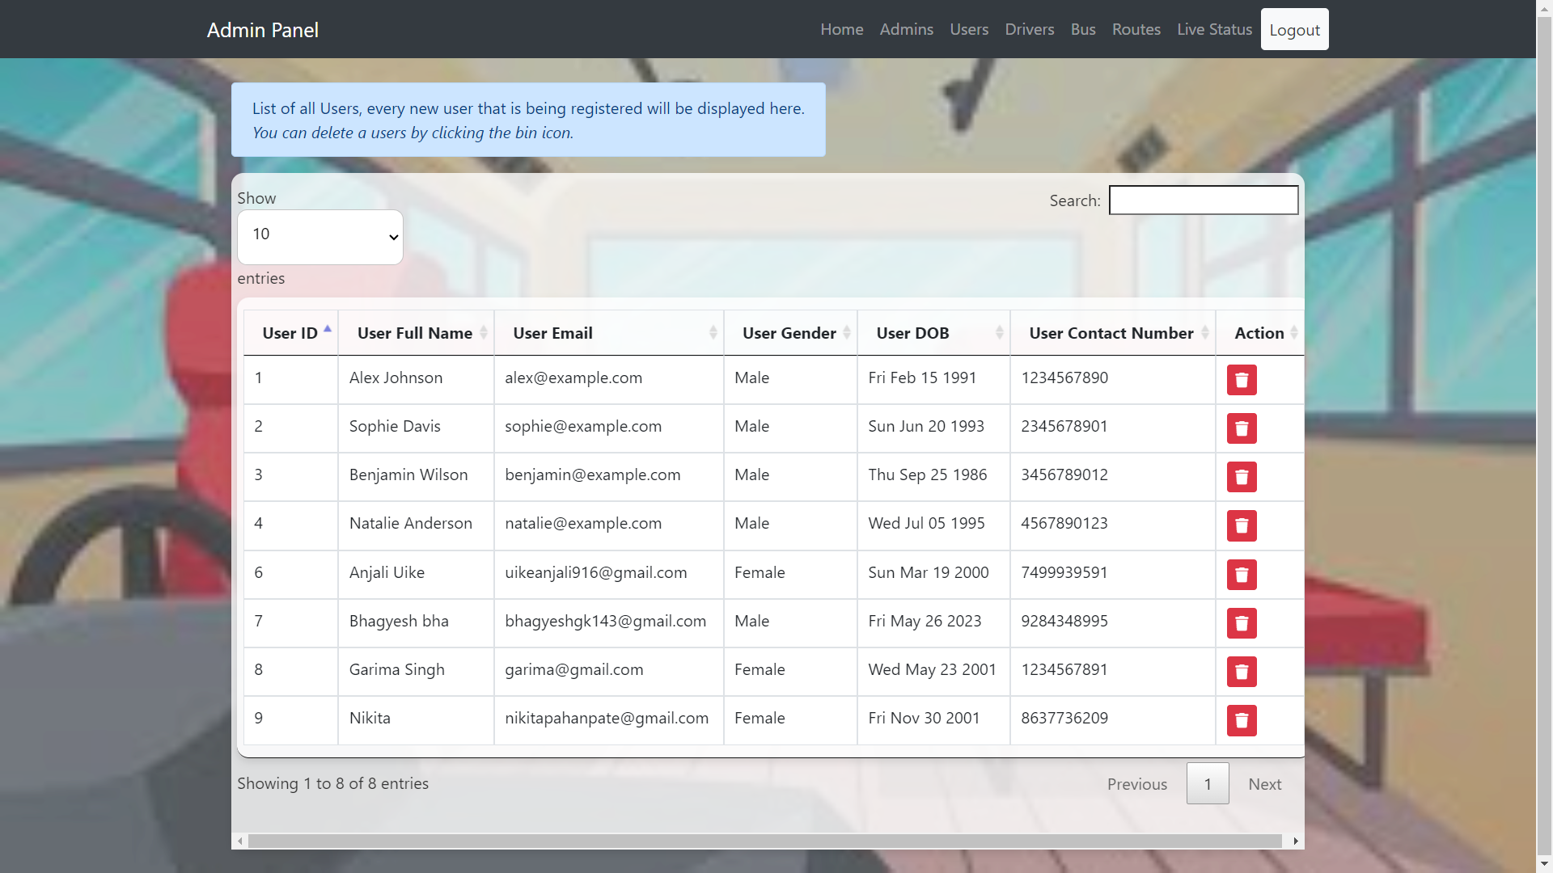
* 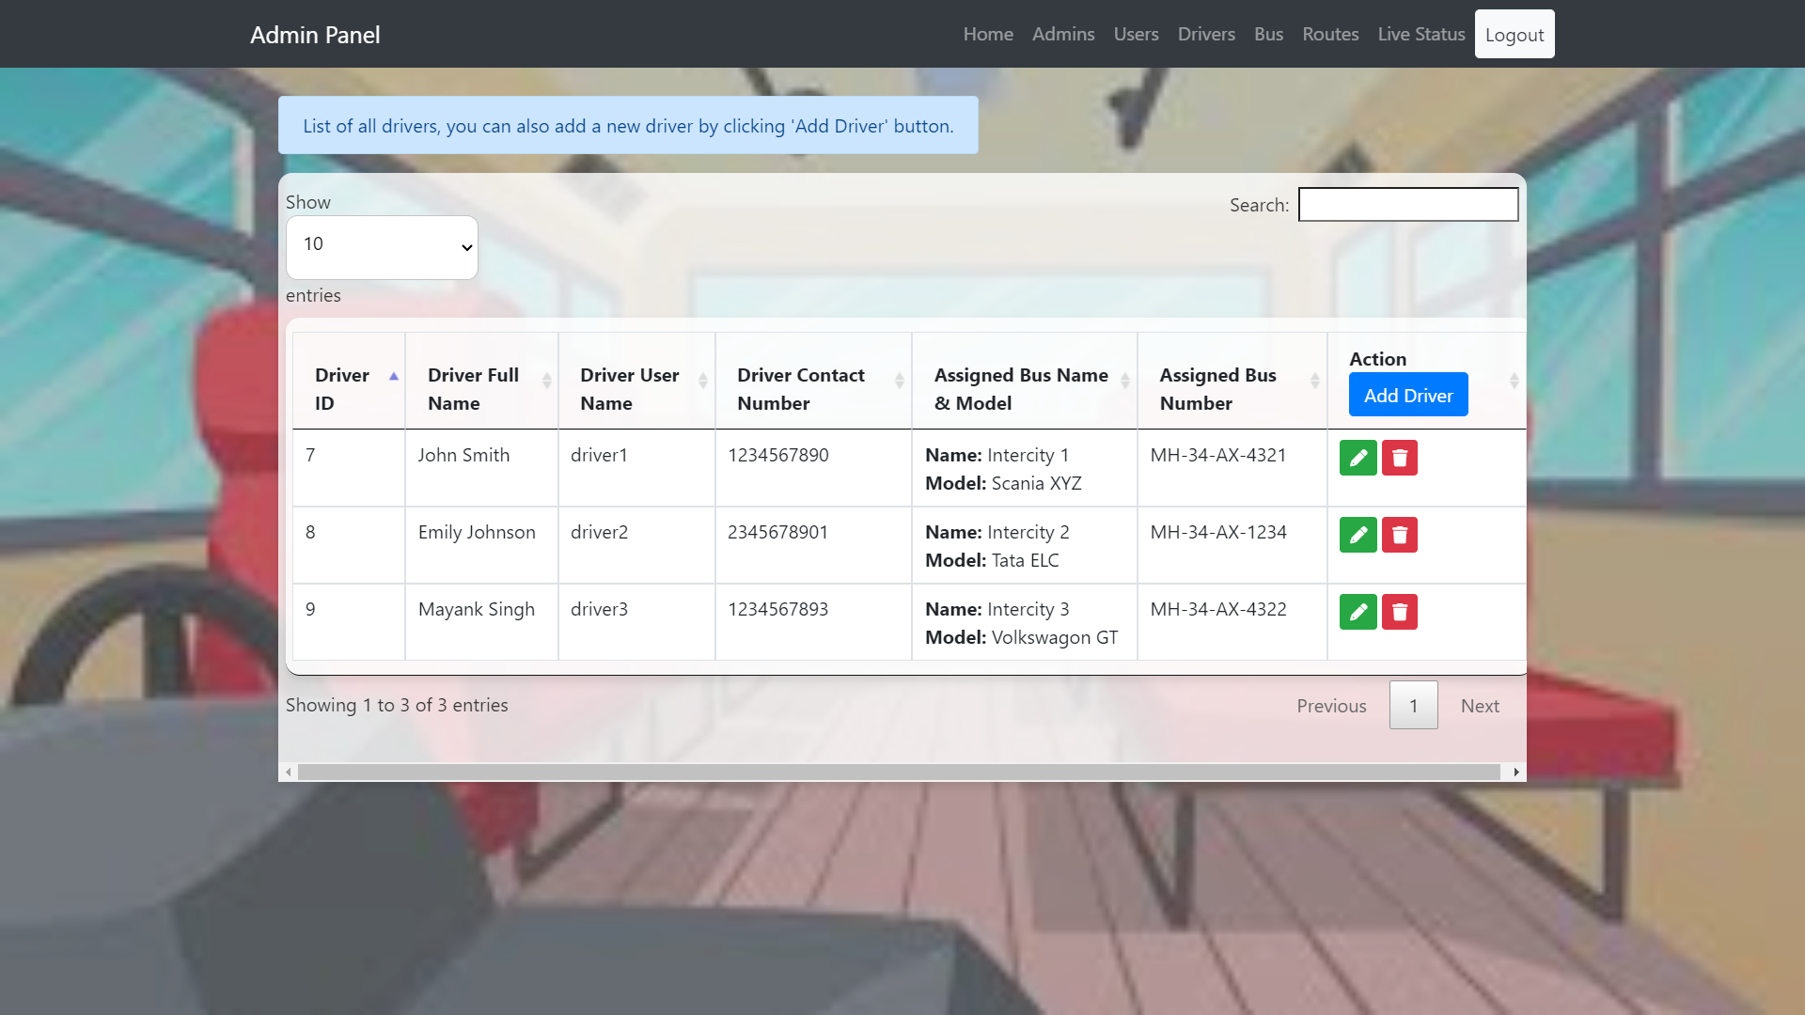
* 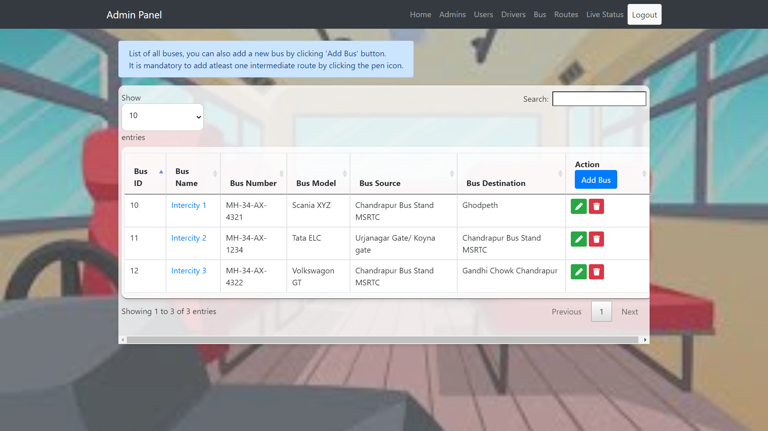
* 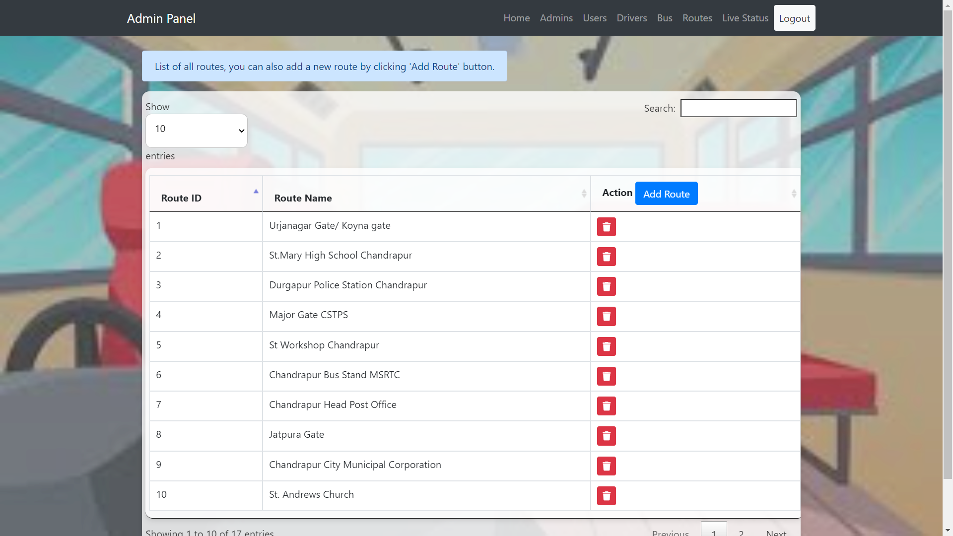
* 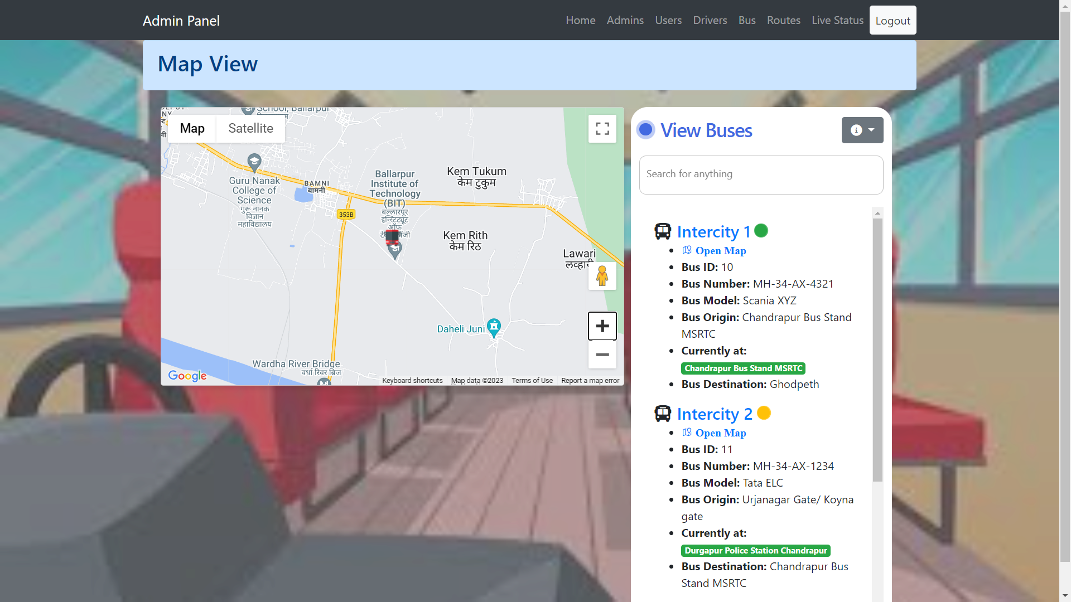
* 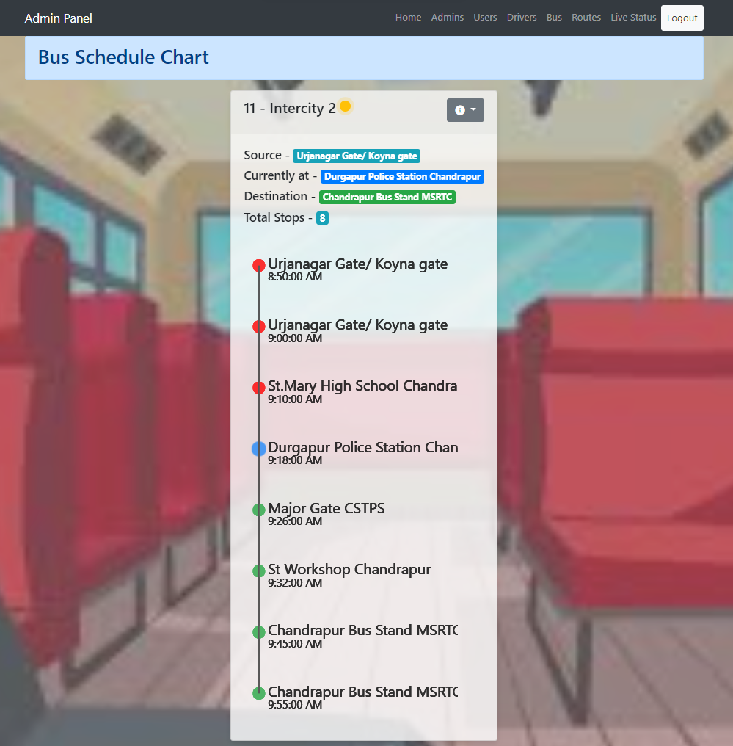
* **Driver**
* 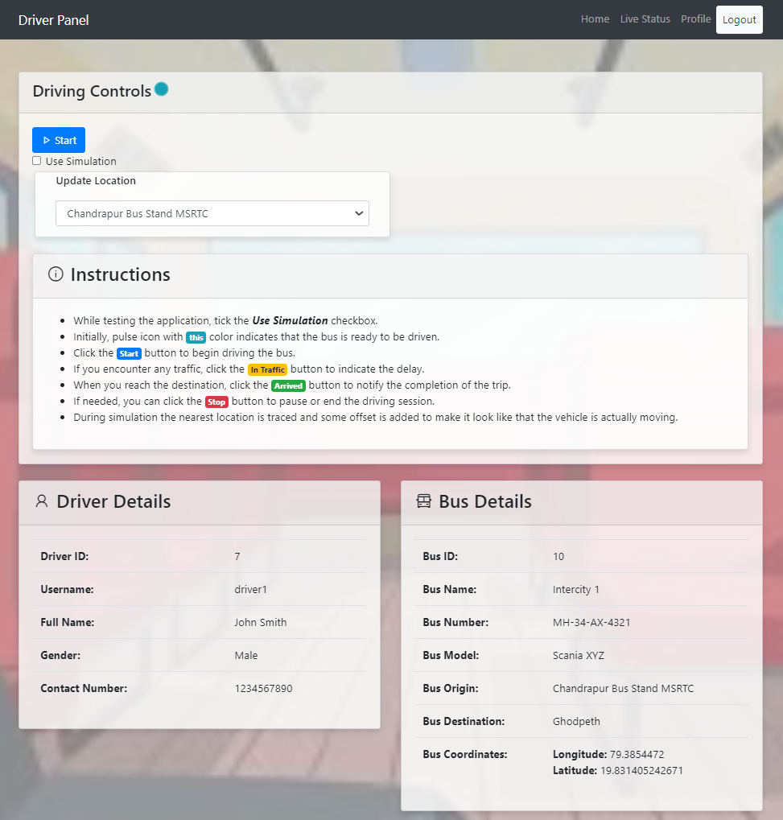
* User
* 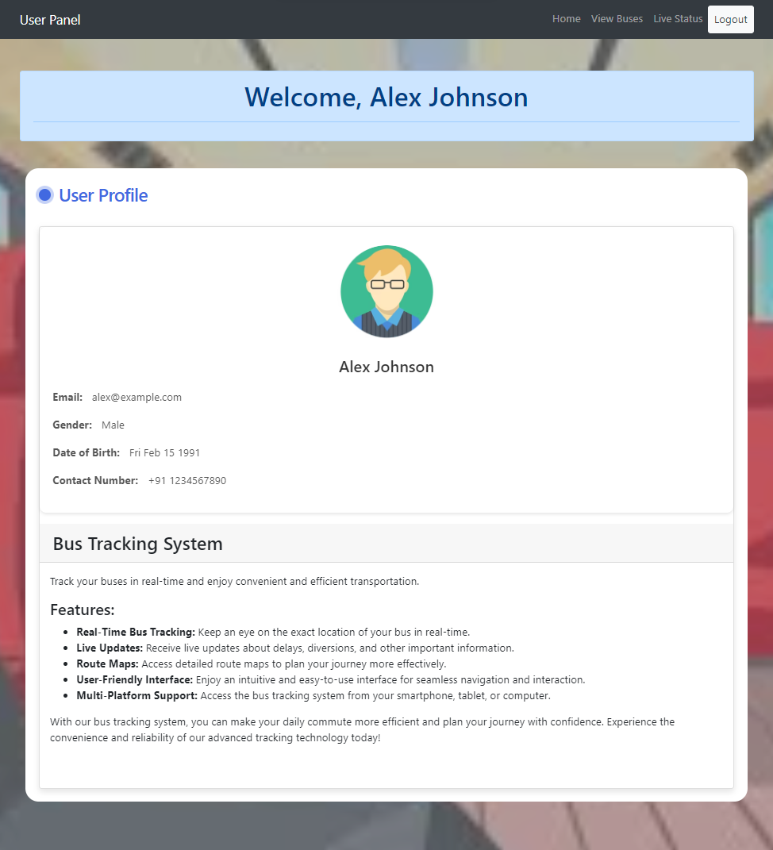
* 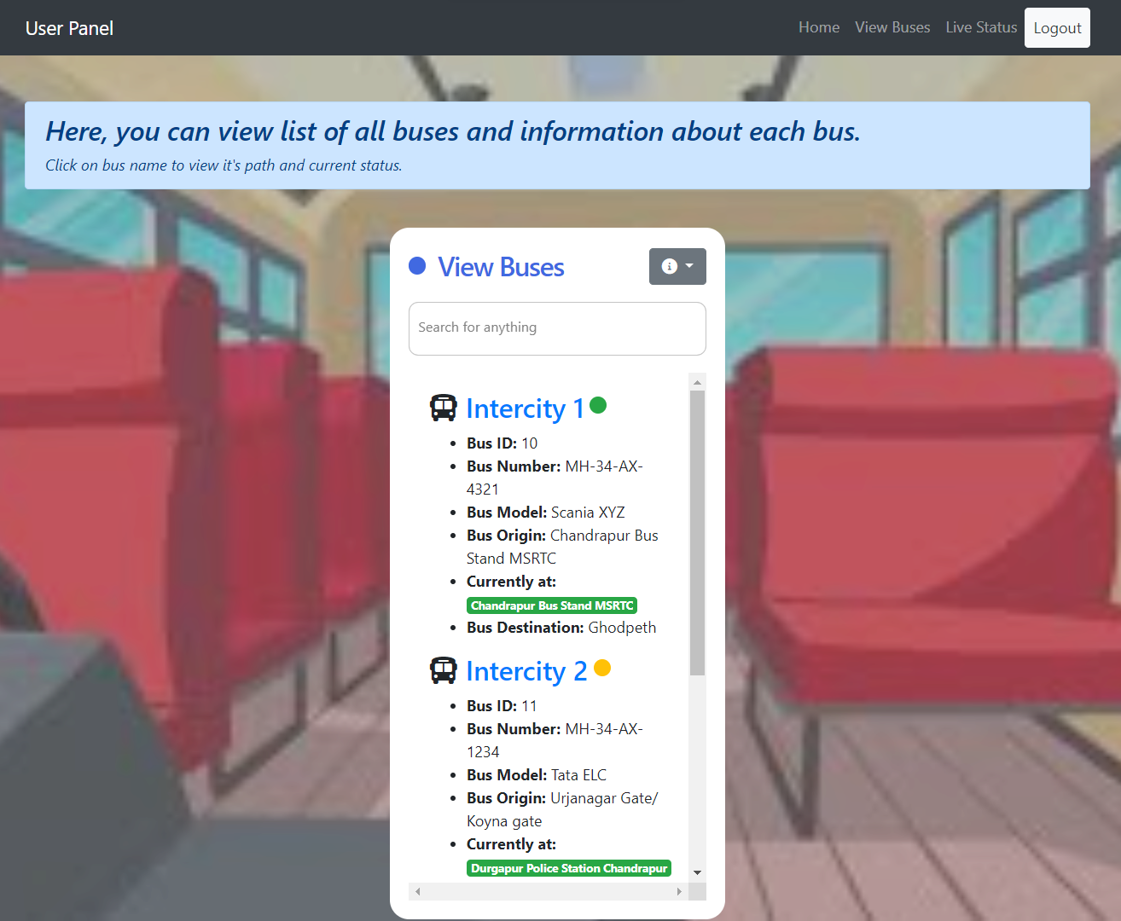

**Conclusion**

In conclusion, the location tracking system for buses is a successful project that provides an efficient and reliable solution for tracking the real-time location of buses. The project has been developed using various technologies and methodologies to ensure the accuracy and effectiveness of the system.

The system offers several key features that cater to both administrators and users. Administrators have access to an intuitive web interface where they can manage user accounts, driver information, bus details, and route information. They can add new users, assign drivers to buses, update bus stops, and track the live status of buses on a map. This functionality empowers administrators to efficiently manage the transportation system and make informed decisions based on real-time data.

For users, the system provides a user-friendly platform where they can register, log in, and track buses on a map. Users can easily access information about bus routes, including origin, destination, and stops, enhancing their travel experience and ensuring efficient planning. With the ability to track buses in real-time, users can make informed decisions about their journeys, optimize their travel time, and stay updated on any changes or delays.

The utilization of technologies such as Express.js, PostgreSQL, socket programming, and APIs contributes to the overall robustness and functionality of the system. These technologies enable seamless communication between the web application, the server, and the database, ensuring the accurate retrieval and display of bus location data. The database plays a crucial role in storing and organizing the relevant information, allowing for efficient data retrieval and management.

Throughout the project, a systematic approach was followed, including requirements gathering, database design, user interface design, and backend and frontend development. This ensured that the project was executed in an organized and structured manner, resulting in a well-designed and functional system.

Overall, the location tracking system for buses serves as an effective solution for enhancing the management and tracking of buses. It provides administrators with the necessary tools to efficiently manage bus operations, while users benefit from accurate and real-time information for planning their journeys. The successful completion of the project demonstrates the effective utilization of technologies, adherence to the research methodology, and the ability to deliver a reliable and user-friendly solution.

**Future Scope**

The location tracking system for buses has a strong foundation and offers valuable features for bus management and user convenience. However, there are several potential areas for future enhancement and expansion. Here are some future scope possibilities for the project:

1. Mobile Application: Develop a dedicated mobile application for users to track bus locations, view route information, receive notifications, and access additional features on their smartphones. A mobile app would enhance the user experience and provide more flexibility and convenience.

2. Real-Time Notifications: Implement a notification system to alert users about bus arrivals, delays, route changes, or any other relevant updates. This could be achieved through push notifications or SMS messages, ensuring users stay informed and can plan their journeys accordingly.

3. Passenger Count Monitoring: Integrate a passenger counting mechanism to estimate the number of passengers on each bus. This data can be used for capacity planning, optimizing bus schedules, and providing real-time information to users about crowded or empty buses.

4. Advanced Analytics and Reporting: Incorporate data analytics capabilities to generate insightful reports and visualizations. Administrators can leverage this data to analyze bus performance, identify trends, optimize routes, and make data-driven decisions for improving the overall transportation system.

5. Integration with Payment Systems: Integrate payment systems to facilitate online ticket booking and cashless transactions. Users can easily purchase bus tickets through the web or mobile app, reducing the need for physical tickets and cash transactions.

6. Feedback and Ratings: Allow users to provide feedback and ratings for their bus journeys. This feedback can be used to improve service quality, address issues, and maintain customer satisfaction.

7. Integration with External APIs: Explore integration with external APIs, such as weather data, traffic updates, or public transportation APIs, to provide users with comprehensive information and improve the accuracy of estimated arrival times.

8. Geofencing and Proximity Alerts: Implement geofencing technology to define virtual boundaries for specific areas or bus stops. Users can set up proximity alerts to receive notifications when a bus is approaching their desired location.

9. Multilingual Support: Provide multilingual support to cater to a diverse user base. This would enhance accessibility and user experience for individuals who are more comfortable using the system in their native language.

10. IoT Integration: Incorporate Internet of Things (IoT) devices, such as GPS trackers, sensors, or cameras, to gather additional data and enhance bus monitoring capabilities. IoT devices can provide real-time information on bus conditions, environmental factors, and security measures.

These future scope possibilities would further enhance the functionality, usability, and efficiency of the location tracking system for buses. It is important to prioritize and implement these enhancements based on user feedback, technological advancements, and the specific needs of the transportation system.

**Advantages and application**

Advantages of the Location Tracking System for Buses:

1. Improved Efficiency: The system enables efficient bus management by providing real-time bus location updates, allowing administrators to monitor and optimize bus routes, schedules, and resources. This leads to better operational efficiency and resource allocation.

2. Enhanced User Experience: Users can track bus locations in real-time, reducing uncertainty and waiting times. They can plan their journeys more effectively, saving time and reducing the inconvenience associated with unpredictable bus arrivals.

3. Increased Safety and Security: The system enhances passenger safety by providing real-time bus tracking, ensuring that buses follow designated routes and providing visibility into bus movements. It also enables rapid response in case of emergencies or incidents.

4. Better Resource Allocation: By monitoring bus occupancy and passenger demand, the system facilitates optimal resource allocation. Administrators can adjust bus frequencies, capacities, and routes based on actual usage, reducing overcrowding and improving resource utilization.

5. Data-Driven Decision Making: The system collects and analyzes data on bus movements, passenger counts, and other relevant metrics. This data can be used to make informed decisions regarding route planning, schedule adjustments, infrastructure improvements, and resource allocation.

6. Cost Savings: Optimized bus routes and schedules lead to cost savings by minimizing fuel consumption, reducing vehicle wear and tear, and optimizing driver and staff deployment. The system helps identify areas of improvement to streamline operations and reduce operational costs.

**Applications of the Project:**

1. Public Transportation Systems: The location tracking system is valuable for public transportation agencies, such as city bus services, where it can enhance the efficiency, reliability, and user experience of the bus network. It can be deployed in urban areas, suburban regions, or intercity bus services.

2. School Transportation: The system can be applied to school bus services, ensuring the safety and timely arrival of students. Parents and school administrators can track the buses and receive alerts, providing peace of mind and improving overall transportation management for educational institutions.

3. Corporate Transport: Companies with employee transportation services can use the system to track and manage their fleet, ensuring efficient pick-up and drop-off schedules and optimizing routes to reduce travel time and costs.

4. Tourism and Travel: The location tracking system can be utilized by tourism agencies or tour operators to manage tour buses, enabling tourists to track the location of their buses, ensuring timely departures, and providing a seamless travel experience.

5. Shuttle Services: Organizations with shuttle services, such as airports, hotels, or large campuses, can benefit from the system by optimizing shuttle routes, tracking bus locations, and providing accurate arrival times to passengers.

6. On-Demand Transportation: Ride-sharing or on-demand transportation services can leverage the system to track their vehicles, monitor driver performance, and provide users with real-time updates on the arrival and location of their requested rides.

In summary, the location tracking system for buses offers advantages such as improved efficiency, enhanced user experience, increased safety, and better resource allocation. Its applications span various sectors, including public transportation, school transportation, corporate transport, tourism, shuttle services, and on-demand transportation. The system's benefits make it a valuable tool for optimizing bus operations, enhancing passenger satisfaction, and improving overall transportation management.

**Hardware and Software requirements**

**Software Requirements:**

1. Operating System: The system should be compatible with the desired operating system, such as Windows, macOS, or Linux.

2. Database Management System: The project requires a database management system to store and manage data. In this case, PostgreSQL is used as the database system.

3. Web Server: The system needs a web server software like Apache or Nginx to host the web application.

4. Programming Languages and Frameworks: The project utilizes programming languages and frameworks such as JavaScript, Node.js, and Express.js for server-side development. HTML, CSS, and JavaScript are used for client-side development.

5. Socket Programming Library: To implement real-time tracking and communication, a socket programming library like Socket.IO is utilized.

6. Mapping and Geolocation API: The system requires a mapping and geolocation API, such as Google Maps API or Mapbox API, to display maps, track bus locations, and calculate routes.

7. Integrated Development Environment (IDE): An IDE like Visual Studio Code, WebStorm, or Sublime Text can be used for coding and development.

**Hardware Requirements:**

1. Server: A server or hosting environment capable of running the chosen operating system and web server software is required.

2. Computer: Developers and administrators working on the project need a computer system with sufficient processing power, memory, and storage capacity to handle the development tasks.

3. Mobile Devices: To test and demonstrate the mobile tracking functionality, mobile devices (smartphones or tablets) with GPS capabilities are required.

4. Internet Connection: A stable and reliable internet connection is necessary for accessing online resources, APIs, and for real-time communication between the server and clients.

5. GPS Devices: Buses need GPS devices or compatible tracking systems installed to transmit their location data to the server. These GPS devices should be capable of communicating with the server through a network connection.

It's important to note that the specific software and hardware requirements may vary based on the project's specifications, scalability requirements, and deployment environment. The mentioned requirements provide a general outline for developing and running a location tracking system for buses.

References

Here are some references that can be useful for the project:

1. PostgreSQL Documentation: Official documentation for PostgreSQL, the open-source database management system used in the project. Available at: https://www.postgresql.org/docs/

2. Node.js Documentation: Official documentation for Node.js, a JavaScript runtime used for server-side development. Available at: https://nodejs.org/en/docs/

3. Express.js Documentation: Official documentation for Express.js, a web application framework for Node.js. Available at: https://expressjs.com/

4. Socket.IO Documentation: Official documentation for Socket.IO, a JavaScript library for real-time, bidirectional communication between the server and clients. Available at: https://socket.io/docs/

5. Google Maps Platform Documentation: Documentation for Google Maps Platform, a set of APIs and services for building mapping and location-based applications. Available at: https://developers.google.com/maps/documentation

6. Mapbox Documentation: Documentation for Mapbox, a mapping platform for developers offering mapping and location-based services. Available at: https://docs.mapbox.com/

7. HTML, CSS, and JavaScript Documentation: Various resources and tutorials are available online for learning HTML, CSS, and JavaScript, which are fundamental web technologies used in the project.

8. MDN Web Docs: Mozilla Developer Network (MDN) provides comprehensive documentation and guides for web technologies, including HTML, CSS, and JavaScript. Available at: https://developer.mozilla.org/

9. Stack Overflow: An online community of developers where you can find solutions to coding issues, ask questions, and learn from others' experiences. Available at: https://stackoverflow.com/

10. Online Tutorials and Courses: Websites like Udemy, Coursera, and YouTube offer a wide range of tutorials and courses on web development, JavaScript, Node.js, and other relevant topics. These resources can provide in-depth learning and practical examples.

1. Title: "Real-Time Location Tracking Systems: A Survey" Authors: Mahmoud Al-Tabbakh, Wail Mardini, Mladen Veinović Published in: 2018 IEEE International Conference on Electro/Information Technology (EIT) DOI: 10.1109/EIT.2018.8500205
2. Title: "Real-Time Location Tracking Using Bluetooth Low Energy Beacons" Authors: Ka Ho Leung, G. S. Hung Published in: 2016 IEEE International Conference on Industrial Informatics (INDIN) DOI: 10.1109/INDIN.2016.7819252
3. Title: "A Review of Real-Time Indoor Positioning Systems for Mobile User Tracking" Authors: Shuai Hu, Qun Wu, Zhiqiang Zhang Published in: 2015 7th International Conference on Intelligent Human-Machine Systems and Cybernetics (IHMSC) DOI: 10.1109/IHMSC.2015.107
4. Title: "Design and Implementation of Bus Positioning System Based on GPS/GIS and Wireless Communication Technologies" Authors: Qiaona Deng, Xinyu Cheng Published in: 2017 2nd International Conference on Image, Vision and Computing (ICIVC) DOI: 10.1109/ICIVC.2017.8064877
5. Title: "Design of Bus Location System Based on GPS and GSM Technology" Authors: Ke Zhang, Bailing Zhang, Yanping Zhang Published in: 2017 IEEE International Conference on Systems, Man, and Cybernetics (SMC) DOI: 10.1109/SMC.2017.8123135